Digital Marketing Plan of Automobile Companies on TikTok Live Streaming

Applied Project Final Report

By

Yue Mao

Spring, 2022

A paper submitted in partial fulfillment of the requirements for the degree of

Master of Science in Management and Systems

at the

Division of Programs in Business

School of Professional Studies

New York University

***Table of Contents***

Declaration 5

Acknowledgements 6

Abstract 7

Abbreviations and Definitions 8

Introduction 9

Problem Description and Opportunity 11

Importance of the project 13

Automobile Companies Survey 15

Project Objectives and Metrics 16

Alternate Solutions Evaluated 19

Solution Evaluation Criteria 21

Selection Rationale 22

Approach and Methodology 29

Results 32

Risk Analysis 36

Issues Encountered 38

Project Chronology and Critique 40

Lessons Learned 42

Conclusion and Summary 45

Limitations, Recommendations and Scope for Future Work 46

Literature Survey 48

References 55

Appendix A - Project Acceptance Document 58

Appendix B - Project Sponsor Agreement 60

Appendix C - Project Charter 64

Appendix D - Project Plan 76

Appendix E - Risk Management Plan 80

Appendix F - Status Report 82

Appendix G - Annotated Bibliography 92

Table of Tables

Table 1 - Risk Analysis and Scores 36

Table 2 - Risk Matrix 36

Table 3 - Contingency Plan 37

Table 4 - Project Chronology and Critique 41

Table of Figures

Figure 1 - TikTok Advertisement Payment Criteria 24

Figure 2 - Automobile Dealers on TikTok Live Streaming Process 27

Figure 3 - SWOT Analysis of TikTok Live Streaming Marketing Plan 30

Figure 4 - Porter's Five Forces Model of Live Streaming Industry 31

Figure 5 - RACI Matrix 37

NOTE: The **Table of Contents** should follow the title page and list the chapters, their main sections and subsections with the number of the page on which each begins.  It is not advisable to list subsections lower than the third level (i.e. 2.1.1.x) in the table of contents. The page numbers should appear on the right. Please remove this footer in final paper. Make sure to update page numbers once the report has been written.

**NOTE: Table of Figures** (if more than 3 figures). Figures should be numbered as “X-y” where “X” is the chapter number and “y” is a serial number beginning with 1. For example, the third figure in chapter 4 would be numbered Fig. 4-3.They should be centered and with a figure caption.

**NOTE: Table of Tables** (if more than 3 tables in the body of the report). Number tables using same method as figures.

# Declaration

I, Yue Mao, declare that this project report submitted by me to School of Professional Studies, New York University in partial fulfillment of the requirement for the award of the degree of Master of Science in Management and Systems is a record of project work carried out be me under the guidance of Dr. Andres Fortino, NYU Clinical Assistant Professor of Management and Systems. I grant powers of discretion to the Division of Programs in Business, School of Professional Studies, and New York University to allow this report to be copied in part or in full without further reference to me. The permission covers only copies made for study purposes or for inclusion in Division of Programs in Business, School of Professional Studies, and New York University research publications, subject to normal conditions of acknowledgment. I further declare that the work reported in this project has not been submitted and will not be submitted, either in part or in full, for the award of any other degree or diploma in this institute or any other institute or university.

# Acknowledgements

I sincerely thank Dr. Andres Fortino to lead me finish this applied project and Chongyang Fan for his contribution as sponsor of this project and as mentor during this project. I also want to thank all the instructors in the Management and Systems program who I have taken courses with and learned a great deal.

# Abstract

This study indicates current marketing problems of automobile companies and demands of digital transformation in automobile industry. For the purpose of expanding the customer range, automobile companies choose to cooperate with TikTok platform for digital marketing. The goal of this project is to come up with an efficient marketing plan, so that automobile companies could attract more effective customers. This marketing plan will also increase sales volume of automobile companies and divert more customers to regional car dealers. Through the analysis of marketing problems of automobile companies and industry research of live streaming, the direction of marketing plan has been established. After comparative analysis of alternative marketing plans, the clients finally chose the more effective marketing plan. The dealers in different automobile companies opened their own live streaming accounts for car sales, and distributed users information in different regions to their local automobile dealers. In addition, this project also created a website for marketing plan promotion. The benefits of creating this website is to describe details in automobile live streaming marketing plan and attract more users to understand better about this plan. The intended automobile customers and live streaming users would be interested in this website. This website was created by Waterfall method, and other studies including approaches like SWOT and Porter’s Five Force Model. The website in this project was created by WIX and other analysis used tools including SQL and Tableau. As a result, the project provided for clients an effective marketing plan that automobile companies open their own live streaming accounts for car sales, and divert different customer information to local automobile dealers. This automobile live streaming marketing method attracted more customers to have appointments with automobile dealer stores. Moreover, the promotion results and contents of website in this project also got satisfied with clients.

The link of this project website is: https://ym2157.wixsite.com/tiktokautomobile

# Abbreviations and Definitions

**SWOT**: SWOT stands for Strengths, Weaknesses, Opportunities, and Threats, and SWOT analysis is a technique for assessing these four aspects of business.

**WBS**: WBS stands for work break down structure, which is a project management tool that uses a detailed step approach to complete large projects with several pieces.

**Tableau**: Tableau is a visual analytic platform transforming the way we use data to solve problems—empowering people and organizations to make the most of their data.

**Porter's Five Forces**: Porter's Five Forces is a model that identifies and analyzes five competitive forces aspects that shape every industry and helps determine an industry's weaknesses and strengths.

**HTML**: HTML stands for Hypertext Markup Language, which is a markup language for the web that defines the structure of web pages.

**WIX**: WIX stands for Windows Installer XML, is a free software tool that builds Windows Installer packages from an XML document.

# Introduction

## Background information

Nowadays, a number of new platforms and business models have been hatched in the information age. ByteDance is a technology company located in Beijing operating a range of content platforms that inform, entertain, and inspire people across cultures. ByteDance is the developer of the video-sharing social networking services and apps like TikTok and Douyin. It also develops the news and information platform Toutiao. TikTok and Douyin have large number of users around the world. According to data from parent company ByteDance, TikTok and Douyin currently has more than 1.29 billion monthly active users. With the rise of Tiktok and Douyin, traditional automobile companies intend to expand their marketing size through short video and live streaming platforms. To help traditional automobile companies digital marketing transformation, this project will find problems and demands of automobile companies’ marketing situations and provide a digital marketing plan for automobile companies on TikTok platform. TikTok advertisement department plans to create a more effective marketing plan combined TikTok livestreaming with automobile companies. This marketing plan needs to make more efficient use of TikTok platform and have better customer effects on the automobile companies. This project will also include a website design for promoting automobile marketing products on TikTok platform.

## Company Name

ByteDance is the developer of video-sharing social networking services and apps like TikTok, Douyin and Toutiao. The ByteDance advertisement department is located in No. 19 Huayuan East Road, Haidian District, Beijing, China, which operating a range of content platforms for companies to expand their customers. This department provides customer increase plans for different kinds of automobile companies.

## Sponsor Information

The project sponsor is ChongYang Fan, who is a marketing manager in Douyin advertisement department in ByteDance. The project sponsor is an excellent marketing expert with many years of experience in TikTok automobile advertisement department and leads a regional marketing team.

# Problem Description and Opportunity

Nowadays, the traditional marketing mode of automobile companies has certain problems. Some existing marketing methods have attracted a limited number of customers and cannot reach more users. Under the influence of the pandemic, competition in the automobile industry has been fierce in recent years. New opportunities in the automobile industry are constantly grabbing the attention of consumers and impacting the target user groups in the automobile industry. Many automobile companies require new sales stimulation, but the previous marketing strategies such as traditional advertising, celebrity endorsements, and onsite automobile speech cannot meet user demands.

In this situation, traditional automobile companies intend to expand their marketing size through short video and live streaming platforms like TikTok live streaming. With the huge number of users on TikTok platform, it would be a great marketing opportunity to help traditional automobile companies digital marketing transformation and acquire more users. TikTok advertisement platform cooperate with different kinds of automobile companies to provide customer increase marketing plans.

However, the automobile industry has formed a relatively instant marketing system in the previous evolution. Those traditional automobile companies have encountered problems in the process of digital transformation, like improving user conversions for the purpose of transactions, optimizing marketing costs and efficiencies for automotive companies, and maximizing the reach of target users within a given budget. Through survey in this project, the pandemic has affected automobile dealers in many ways. The epidemic has affected car dealers in many ways. For example, the epidemic has caused many customers to reduce their demands to go out and buy cars in offline automobile stores. There are also some customers whose purchase intentions have been affected due to the economic status impact of the pandemic.

Moreover, advertisement investment efficiency and reaching out more potential purchase intention users are key problems during digital process. Most automobile companies use dealer channel models to distribute their sales, and there is a contradiction between the location of live streaming users and the locality of offline automobile dealers. In order to solve this problem better, TikTok advertisement department need to provide a new marketing plan for those automobile companies. The important opportunity of this marketing plan is maximizing distribution efficiency of user clues in the dealer mode.

# Importance of the project

Under the era of digital transformation, automobile companies are facing marketing changes represented by social networks. TikTok has become an important marketing platform for automobile companies and their competitors. With the popularity effect of TikTok, more and more automobile companies choose to join in TikTok and find their digital marketing plan. The importance of this project is helping automobile companies to find an efficient marketing plan and increasing automobile companies’ exposure on TikTok platform.

According to “TikTok Automobile Creator Ecology White Paper”, TikTok has accumulated more than 280 million interested users in automobile industry with year-on-year increase of 37%. Nearly 2.6 million people share automobile contents every day, more than 8,400 thousands of people like automobile contents and more than 11 million people comment on automotive contents. After data tests on TikTok livestreaming, there are more than 10 million livestreaming views and hundreds of millions video viewers every day. More importantly, TikTok livestreaming enterprise account has been popular in customer companies. TikTok livestreaming has become one of the most suitable channels for car viewing and inquiries. On the other hand, many automobile companies have limitation in their traditional store sale methods, especially have influence during pandemic. In face of such a huge user number on TikTok, many automobile companies hope to take advantage of TikTok's platform dividends to successfully carry out digital marketing transformation. They are urgent to search for a method to expand their customer channels. However, TikTok livestreaming marketing is both simple and complex. It needs to catch preferences of users, and it is also necessary to find efficient marketing methods suitable for different automobile companies.Therefore, this project is important and independent, not only for better use viewers’ resources on TikTok live streaming platform, but also help automobile companies to attract more users and reach their marketing goals. Through the marketing plan in this project, auto companies could gain more exposure on the TikTok platform and can reach larger number of users. This project provides new marketing growth ideas for automobile companies, and aims to help automobile companies increase sales volume through cooperation with TikTok platform.

# Automobile Companies Survey

In order to conduct a more in-depth analysis of the specific situation of auto companies and Douyin's live broadcast cooperation, this project conducted surveys on some representative auto companies and car dealers that cooperated with TikTok platform.

The first company was BMW.

# Project Objectives and Metrics

## Goal of the project

Traditional automobile companies are undergoing digital marketing transformation. This project will find problems and demands of automobile companies’ marketing situations and provide a digital marketing plan for automobile customers on TikTok platform. TikTok advertisement department plans to create a more effective marketing plan combined with TikTok live streaming for automobile brand customers. This marketing plan needs to make more efficient use of TikTok live streaming platform and have better customer effects on the automobile companies. This project will also include a website design for promoting automobile marketing products on TikTok live streaming platform.

## Project Deliverables and Metrics

Object 1 – Write a live streaming industry trend analysis and calculate data from financial statements & Questmobile. Use Tableau to analyze data.

Measurement: Finish the live streaming industry data analysis by the Mar 8th, 2022.

Object 2 – Contact with my sponsor and interview some automobile companies to find traditional automobile companies’ marketing problems.

Measurement: Finish the typical automobile companies’ marketing problems and demands report by Mar 25th, 2022.

Object 3 – Provide a digital marketing plan for automobile companies in TikTok live streaming to attract more customers.

Measurement: Deliver the digital marketing promotion plan by Apr 5th, 2022.

Object 4 - Create a website to promote automobile customers’ marketing products in TikTok live streaming and provide the registration system for users.

Measurement: Deliver complete website and report accepted by client by May 3rd, 2022.

**Project Evaluation**

Project success was evaluated by certain evaluation criteria, including whole project outcomes, project report and presentation, project website accomplishment, project schedule, project communication plan, issues log, risk register and project status reports. These are valuable criteria for project evaluation assessment.

1. Project schedule

This project will meet the milestone deadline and the final due date. The client and project sponsor will sign the project completion document, project acceptance document before the due date to make sure this project will be delivered on time. Successful completion of all reports by the final project deadline is one evaluation criteria of project success.

1. Project outcomes

The outcomes of the project is an important measures of project success. The contents of this project should conform to the submitted objects and metrics, and meet the requirements of the project team and clients. The results of this project should have certain conclusions and outcomes, which is an important project criteria.

1. Project website accomplishment

This project also contains a web page promoting the marketing plan. The website is also an important deliverable of project. The project also contains a web page promoting the marketing plan. It is an important condition for the success of this project that the web page will publish on time, and the contents of marketing plan are completely displayed on this website. The quality of the web page should be approved by the project clients.

1. Project report and presentation

The project report and presentation will be an important evaluation criteria of project success. Completing the project report with quality is one of the necessary criteria for the success of the project, including completing each part of the project report, meeting the length of the project requirements, matching the format of the project. Meanwhile, a comprehensive presentation of the whole project contents to professor and project sponsor is also one of the important criteria for the project success.

5.Project regular communication

The regular communication and status report of this project is also important for project success. Project manager should have weekly meetings with clients about the project progress and project plan in the next steps. The project manager will also need to submit project status reports, risk analysis report and change management plan, which will tell clients what the project situation is. The project required to finish those reports and get assigned by client that agrees the contents of project.

# Alternate Solutions Evaluated

Regarding effective digital marketing plans for automobile companies on TikTok platform, automobile companies have two important advertisement marketing solutions on the TikTok platform.

The first marketing solution is automobile companies cooperate with short video celebrity bloggers to make automobile short videos. Those short videos attach a link that could make an appointment for drive tests in order to attract more users for automobile companies.

Pros:

This solution could receive benefits from the fans effect of celebrity bloggers. Under this solution circumstances, the celebrity bloggers always have millions of followers, and the short videos they make will give valuable promotion effect to automobile companies. This kind of promotion value will bring potential user growth to automobile companies, and it is a very effective advertisement solution. Since the pandemic, people couldn’t go directly to the automobile store for automobile purchasing. Short videos are readable, attractive and interactive, which are efficient ways for customers to learn about desired car types and description. Indeed, many automobile companies have brought advertisement through TikTok short videos and cooperate with celebrity bloggers. Moreover, This marketing solution will insert a link below short videos that is convenient for users to leave their contact information and make an appointment to see the car offline. This solution is more direct and convenient for users to operate, and attract effective users to a greater extent.

Cons: However, this marketing solution also has some drawbacks. Usually, it is expensive to invite celebrities to create short videos for promotion, which greatly increases the marketing budget of automobile companies. In addition, some automobile companies indicated that celebrity bloggers do not have a comprehensive understanding of the car functions.They cannot fully and accurately locate the preferences and needs of target customers, which affects the accuracy of short video contents.

The second marketing solution is automobile companies and dealers open their own TikTok accounts to sell cars through live streaming. Through the live streaming portal of TikTok, the sales staff of dealers could act as anchors to sell cars live on their own, and start the online car promotion mode.

Pros:

On the one hand, the online live-action car review model provides consumers with a comprehensive introduction to new car information and store activities, and fully interacts with consumers. On the one hand, this marketing solution enable automobile companies conduct efficient user maintenance through TikTok live streaming platform, and accurately attract more users to automobile dealership stores. In this way, the brand information of automobile companies can be exposed in large quantities, which allows consumers to obtain valuable car information in real time. Moreover, In the car live streaming room, automobile stores could directly put the registration link to intended customers, which is convenient for car dealers to obtain more customer information.

Cons: Some sales practitioners of car dealerships have no experience in live streaming on TikTok. They are unfamiliar with methods of live streaming and operation strategy of how to attract users. They need to conduct systematic live streaming training to improve their user conversion rates and accumulate their user databases.

# Solution Evaluation Criteria

There are some criteria for selecting a marketing plan, including the business effects that these alternate marketing plan solutions can bring to automobile companies, the number of users that can be reached. In addition, the cost criteria is also an important factor to evaluate alternate solutions.

Business Function Evaluation Criteria

The business function evaluation criteria of marketing plan solutions is primary factor in the choice of automobile companies to cooperate with the TikTok platform. The commercial value of the marketing plan is the primary factor in the choice of automobile companies to cooperate with the TikTok platform. In the process of choosing cooperation, automobile companies mainly evaluate the business effects of marketing plans. Including brand exposure, actual number of registered users and products sales volume increase.

Cost Evaluation Criteria

In addition, the cost of cooperation is also an important factor for automobile companies to consider in the process of cooperation. Those automobile companies not only pursue the desired business results, but also cost of cooperation is an important criterion. In the process of cooperation, automobile companies tend to choose the most cost-effective advertisement cooperation method, maximizing the use of costs, ensuring advertisement delivery, and accurately reaching more customers.

# Selection Rationale

The short video celebrities promotion marketing solution and automobile companies dealer live streaming promotion plan have their own advantages and disadvantages. This part explains how to select an appropriate marketing solution based on solution evaluation criteria. The goal of this marketing cooperation and most important factor that automobile companies concerned is actual number of registered users. Only customers who have made appointments for a test drive or made a successful transaction in offline stores through short video marketing can be counted as an effective user conversion for short video marketing. At the same time, the cost of marketing cooperation programs is also an important measure criteria.

**Short Video Marketing Plan**

Business Function Evaluation

First of all, in terms of brand exposure criteria, TikTok short videos can provide automobile companies with different advertising promotion methods, including information flow advertisements, search advertisements, open-screen advertisements and other advertising forms. Promoting the deep cultivation of the top talent industry and the diversified development of content, content ecology of TikTok automobile companies has been great improved. The exposure of this marketing solution meets the standard of reaching more users.

Secondly, TikTok short video platform has a huge number of people interested in automobile contents. Short video promotion solution could use content marketing methods to reach out more customers. By expanding brand influence with different car short videos, automobile companies cooperate with car experts or celebrities to convert their fans into automobile companies customers. The commentary and fan effect of TikTok celebrities in short videos convert their fans into automobile companies’ registered customers. At the same time, this solution demands short videos contents match the communication methods of consumer in the automobile industry and customize ingenious content dissemination. In this way, this can precisely reach the loyal fans of hundreds of millions of auto content and help auto companies discover target customers.

However, some problems also occurs in this solution. When celebrities explain car products or brands in a short video of minutes, the content of these short videos have difficulties to describe specifically the performance, appearance, and advantages of different cars. It has problems for short video advertisements to meet the expectations of automobile companies for the effect of product or brand communication if the video capacity is too small.

Cost Evaluation

The cost evaluation is also an important criteria for automobile companies to consider. If automobile companies choose to cooperate with TikTok celebrities, the corresponding short video charging standard is based on the number of followers of celebrities and the length of the video. According to normal circumstance data, if the number of fans of Internet celebrities is more than 10 million, then the quotation for promoting a short video is between 500,000 and 1,000,000. The above is determined according to the length of the video. Therefore, cooperation with Internet celebrities is still require high cost, and additional short video cooperation payment is required.

In addition to cooperating with Internet celebrities, there are other basic advertisement payments criteria on the TikTok platform. This part of the billing method is accountable and transparent, which mainly has following three charging standards.

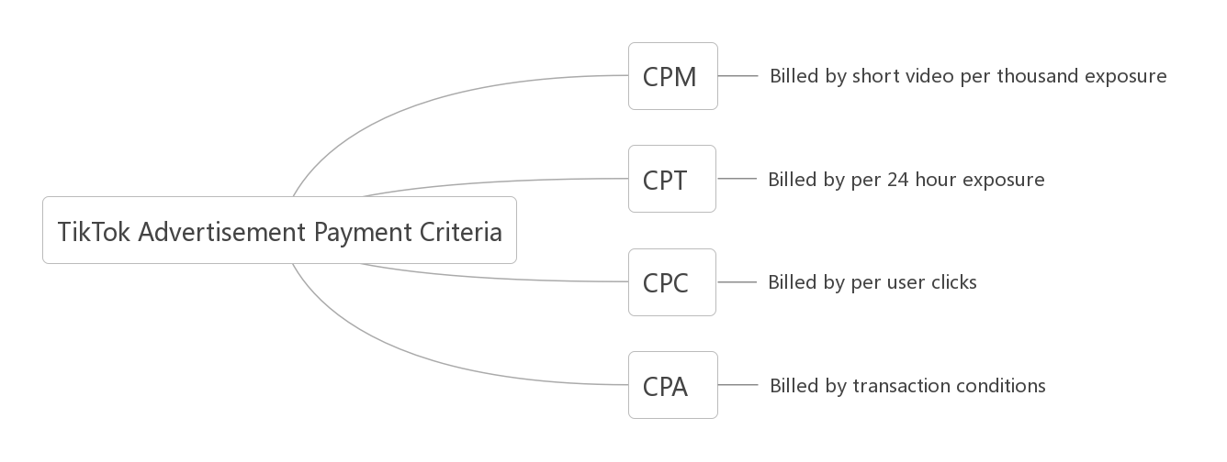

Figure 1. TikTok Advertisement Payment Criteria

1. CPM

The first CPM payment method is based on thousand user exposure, and one thousand times is a billing unit. More specifically, when the advertisement link of automobile companies in short videos is displayed 1,000 times on TikTok platform, the system will charge one unit fee.

1. CPT

CPT payment method on TikTok is charged according to 24 hours of exposure, that is, advertisements are placed at any time within 24 hours. As long as users open TikTok, they can see the advertisements. No matter how many times they are exposed, they are only charged once within 24 hours.

1. CPC

The CPC payment method required for each time an advertisement is clicked by user. If an advertisement placed by an advertisement is clicked by a user, the system needs to charge a fee. When the customer clicks on the advertising link promoted by the advertiser, and the TikTok short video advertisement system software will deduct the advertisement.

1. CPC

The CPA charging model is based on user transaction fees. It has three charging methods. The first is charging by telephone. The number of people who call the advertiser will be charged according to the number of times. The second is charging according to the personal information form submitted by the user. The third is for APP promotion, it depends on how much is charged for a single APP to be downloaded once, which is currently limited to Android phones. This advertising method has wide coverage and high advertising investment efficiency.

In conclusion, TikTok's short video promotion and cooperation with Internet Celebrities could bring more exposure and customer clicks to automobile companies, so as to achieve a certain marketing effect. But at the same time, the promotion of short videos in cooperation with celebrities requires additional fees. Moreover, the customer conversion rate of short video promotion is uncertain. Many customers just click on the advertising link, but do not really make an appointment for a test drive. More importantly, the location for test drive appointments left by many customers comes from all over the country and cannot be matched with the corresponding car dealership stores. Therefore, automobile companies are looking for a more efficient marketing method.

**Automobile Live Streaming Marketing Plan**

In the current pandemic period, consumers have reduced their offline activities and the potential demand for online purchases has increased significantly. In order to solve the difficulties of offline car viewing and the uncertainty of the conversion rate of short video users, TikTok has fully opened the live streaming function to automobile companies across the country. Many automobile companies and dealer stores open their own TikTok accounts to operate their private domain customers. After the account is opened, dealers can fully use the user resources and have close connection with potential consumers on TikTok livestreaming. Moreover, this solution could provide consumers with a package of services such as online car viewing and pre-sale consultation, so as to solve the demand points of consumers who are unable to view cars offline and contact potential car consumers.

Business Function Evaluation

Under the influence of the pandemic, more and more automobile companies choose to join in TikTok live streaming and sell their cars online. There are also some automobile companies that have opened official TikTok accounts and built online car cloud stores to meet the demands of users to view cars more conveniently.

The commercial effect of TikTok's live streaming marketing solution is really efficient. As long as consumers comes to watch the car explanation in the live streaming, it may bring sales. Knowing the car emperor data shows that over 5000 dealers have opened TikTok live streaming, which covering nearly 80 brands. The marketing method of live car sales allows the dealers of auto companies to reach more intended users accurately, and in the live broadcast room, professional front-line car sales staff can better interact with users, establish contacts, and get Really effective client appointments. Automobile companies’ online live streaming also meet some issues that automobile companies encountered. During automobile companies’ live streaming, some potential car buyers from all over the country may see the contents of one automobile company, so there is a contradiction between the locality of offline car stores and online appointments opening. According to the data on platform, 80% of the customer clues received by dealers in the live broadcast are from different locations. This kind of different location customers always can not be promoted to correct location efficiently. In this situation, a large number of clues from different places are wasted. This previous system has caused a large loss of potential users of auto companies' live broadcasts.

To deal with this problem, TikTok live streaming automobile department provide an creative marketing plan solution. This marketing plan provide car cloud store service for automobile companies, which has circulation of customer clues in different places. After opening the car cloud store service, dealers can forward the clues from different locations to the correct manufacturer within one second, and the system automatically helps the manufacturer to send customer clue information. By distributing different customer location to the appropriate dealers, 80% of the different location customer clues changed from invalid to effective. It is obvious that the automobile company livestreaming solution is more efficient to attract more effective customers.

The solution of TikTok Live streaming Car Cloud Store has greatly improved the marketing efficiency of auto companies in terms of commercial impact, really reached more effective users, and brought real sales to auto companies.

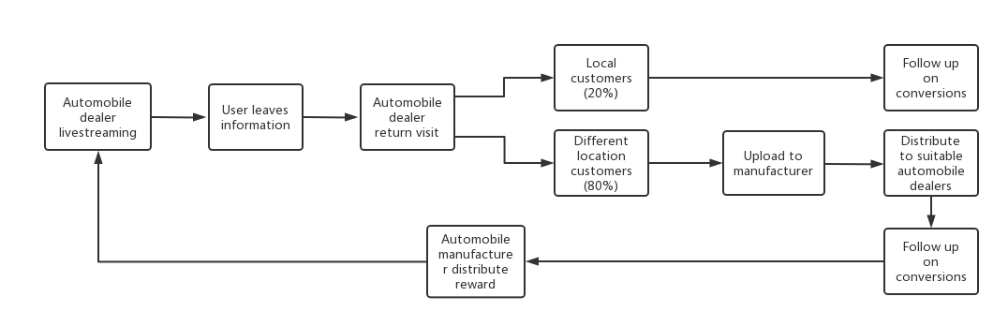

Figure 2. Automobile Dealers on TikTok Live Streaming Process

Cost Evaluation

The cost evaluation is also an important criteria for automobile companies to consider. Automobile companies choose to cooperate with the TikTok platform to open their own accounts for live streaming. This method is more cost-effective, requires less cost, and saves the high cost of short video cooperation with Internet celebrities. However, some automobile dealers do not have mature live streaming experience and need to cooperate with the TikTok platform to participate in live streaming training. Also, the products sold in live streaming need to pay commission for TikTok platform.

Moreover, when some automobile dealers first opened their own accounts for live streaming, they did not have very large number of viewers as online celebrities. The number of viewers in their live streaming room is not sufficient. In this situation, the automobile dealers live streaming needs to invest certain budgets for viewers promotion. They may need to buy product named Dou+, which is a video heating tool for TikTok creators. It can effectively increase the amount of video viewers and improve the exposure of contents. This investment of Dou+ could also help automobile dealers to let more users see their live streaming status and watch their live streaming room.

Therefore, the main costs of the live streaming marketing model of automobile companies including commission fee with TikTok and the promotion fee on the TikTok live streaming platform.

# Approach and Methodology

The standard approach and methodology in this project including Work Breakdown Structure, SWOT Analysis and Porter Five Forces Model. In addition, approach and methodology in creating website in this project including Agile software development cycle. The procedures of using methodology in creating a website including registering domain name, determining company information, preparing website contents, and writing website code.

Work Breakdown Structure

The first methodology is Work Breakdown Structure. This methodology is one of the most efficient project management method. WBS Project Management shows the overall project work and deliverable of my whole project. WBS Project Management is that it provides all my project team members, including project manager, project sponsor and clients a comprehensive understanding of where their responsibilities fit into the overall project management plan. The WBS also gives them an indication of the impact of their work on the project as a whole. By checking specific tasks and timeline in WBS sheet, the project sponsor and client could mark the process of whole project and communicate with project manager.

SWOT Analysis

The second methodology is SWOT analysis. By using SWOT Analysis methodology, it helps clients to discover the internal strengths of TikTok live streaming marketing plan, and provides opportunities for automobile companies. Our project team determining automobile companies’ problems and opportunities from SWOT analysis methodology and have more clear understanding about the situation of automobile companies, which helps provide their choice of digital marketing plan.

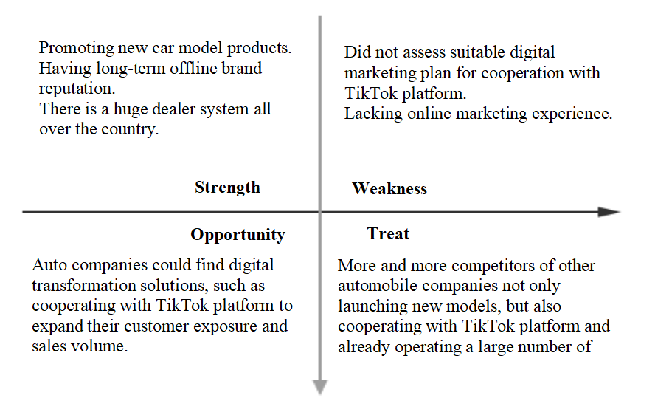

Figure 3. SWOT Analysis of TikTok Live Streaming Marketing Plan.

With the SWOT analysis methodology of automobile companies, this project analyzes the existing problems of traditional auto companies more clearly, and finds possible opportunities for auto companies.

Porter Five Forces Model

This project uses Porter Five Forces Model in the industry analysis part. This Porter Five Forces Model helped project manager analyze is a framework for understanding the competitive forces, factors affecting profitability, competition and developing strategies in the live streaming industry. This theory is based on the concept that there are five forces that determine the competitive intensity and attractiveness of a market. Porter’s five forces help to identify where opportunities lies in a business situation. This methodology is useful both for project manager to understand the strength of live streaming industry, and whether new marketing plans are potentially profitable.

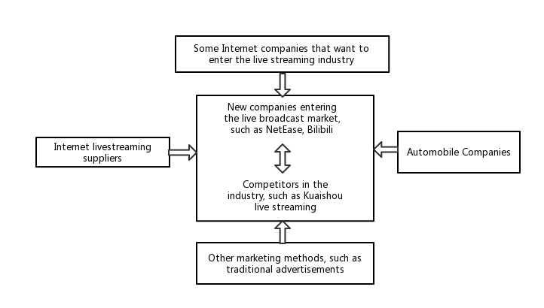

Figure 4. Porter's Five Forces Model of Live Streaming Industry.

Through the Porter's Five Forces Model, the threat of other competitors is more clearly analyzed in the company's industry research, and the importance of launching a competitive and innovative marketing plan for the project department is more profoundly reflected.

Waterfall and Agile Methodology

The Waterfall methodology is a sequential development process that flows through all phases of this project. By using Waterfall development methodology, the whole process of this project like requirements, design, implementation, testing and maintenance will be self-contained and work independently, which could provide a more predictable release schedule. This Waterfall development methodology greatly improved the teamwork and communication efficiency of this project. During the process of creating website, the Agile Methodology Agile is also an iterative methodology to help this project website development that helps our teams provide more efficient deliverable to project clients. Agile project management helped our team focus on breaking down large projects into more manageable tasks, which is more flexible to adapt to project change management plan.

# Results

This project found that the automobile industry is experiencing the marketing shock during the pandemic, and there is a great demands for these automobile companies to broaden their marketing channels through digital transformation. In cooperation with the project sponsors of the TikTok platform, this project studies in detail the two main ways of cooperation. The first method is automobile companies cooperate with Internet celebrities on TikTok platform, and the second method is automobile stores opening their own live streaming accounts for car sales. By analyzing the commercial functions and consumption costs of the two marketing methods, it is found that the marketing mode of cooperation between automobile companies and Internet celebrities requires a high cost of short video production and complex advertisement billing methods, like short video advertisement fees counted by number of viewers or counted by time. But this method that automobile companies have cooperation with Internet celebrities may not necessarily achieve the conversion of real appointment customers. But the time limit of short videos and the fact that Internet celebrity bloggers do not necessarily know the specific information of cars have brought new problems to the automobile digital marketing. Those automobile companies still have questions about how to convert users on the TikTok platform into effective customers who actually make appointments to see and buy cars in offline stores. In response to these problems in the short video marketing methods of automobile enterprises, this project proposes another marketing method. Automobile companies could connect to their dealer stores across the country, each dealer will open its own live streaming account and directly interact with users. Meanwhile, the result of his live streaming marketing method could distribute user data from different regions into their local dealer information system where they are located. The result of this method has greatly improve the sales volume of automobile enterprises, the real conversion rate of users and maximize the user resources on TikTok live streaming platform. Moreover, this marketing solves the problem that the conversion rate of real users of auto companies and the number of people who book to see the car have not been accurately improved. The proposal of this marketing model provides a new opportunity for the digital transformation plan of automobile enterprises.

The result of marketing plan in this project is that automobile enterprise clients are very satisfied with the current new marketing plan, which brings them extremely high marketing efficiency and satisfactory marketing effects. By opening their own live streaming accounts and using the user feedback system in different location, this new marketing method helps more automobile companies cooperate with the TikTok platform. At present, the number of car dealers who have cooperate with live streaming on the TikTok platform has reached nearly 5,000 covering nearly 80 brands. Through the live broadcast, the users on platform with high intention and comments of various automobile companies have increased by 4.7 times. Also, the number of automobile companies and dealers live broadcasts increased by 2.6 times, which greatly attracted more customers for automobile companies.

In addition, the result of this project also include a marketing plan promotion website. This web page contains a detailed introduction to the contents of the TikTok Car Cloud Store marketing plan. This website including the specific contents of marketing plan in this project, the live streaming process of automobile companies and the screenshots of car dealer's live streaming page. This web page introduces the features of this marketing plan to users in details, such as how to interact with the car dealers in the live streaming room of automobile companies, what kind of information can be obtained, and the precise contact with the local car dealer. More importantly, this web page also has an system for users to register and leave their contact information, which can further attract customers through the promotion of the web page. This web pages play a more influential role in promoting the marketing plan adopted by the automobile companies in this project, allowing users to better understand the benefits of car sales live streaming through pictures, information and interaction, and attract more users to participate in car live streaming on TikTok platform. The marketing effects for automobile enterprises is further improved by this website.

As a result, the project sponsor and clients were satisfied with the web page and approved the contents and design of the web page. The client thinks that the project shows the details of this marketing plan well and brings users a good browsing experience.

## Repository of Data Sets and Code

The data sets created for this project and the code for the tool may be found at: https://github.com/Mrspianist/M/upload/main

## Summary of Results

In conclusion, we found that automobile companies are facing some marketing problems under the pandemic and needs new marketing solutions for digital transformation. This project studies the cooperation between auto companies and the TikTok platform for digital marketing plans. Through criteria analysis of business effects and costs, the more effective marketing is that automobile dealers open their own live streaming and conduct live car marketing, and send users from different regions to different dealers of the same brand. This marketing method involves auto dealers themselves in the process of online marketing, which has been recognized by auto enterprise customers, and more and more auto enterprises have joined this marketing method. At the same time, the web page in this project has played an effective role in promoting the marketing plan, and the project sponsors and clients have approved the marketing promotion of website in this project.

# Risk Analysis

In this report, risk analysis and contingency strategies in advance is of efficient help to this project. By listing the potential risks in this project and grading the corresponding risks with probability scores and impact scores, the project risk analysis emergency strategies are planned in advance for risks with higher influence and probabilities.

Some risks in this risk analysis list actually happened during the project. The contingency plan in this risk analysis has made an effect on solving real project issues. Firstly, one of the risks that project have difficulty in finding sufficient data during industry research has happened during the industry analysis process. In face of this scenario, project manager has an efficient meeting with project sponsor and teams as soon as possible, in which project team discussed and evaluated the contingency plan for this risk. Finally, the project team accepted the contingency plan for this risk that industry analysis will select existing database fields, find multiple datasets and related literature. Based on the industry research of existing materials and literature, the industry research part of the project was successfully completed and met requirements of clients.

The second

The first graph in this analysis plan is risk analysis and scores.

**Risk Analysis and Scores**

|  |  |  |  |
| --- | --- | --- | --- |
| **Number** | **Risk** | **Probability Score (1,2 or 3)** | **Impact Score (1,2 or 3)** |
| 1 | Not completing the project on time | 1 | 3 |
| 2 | Project budget decrease and affect website quality | 2 | 2 |
| 3 | Project quality does not meet clients’ requirements before deadline | 2 | 3 |
| 4 | Project have difficulty in finding sufficient data during industry research | 3 | 2 |
| 5 | Lack of website design skills | 3 | 3 |
| 6 | Unforeseen automobile companies refusing to receive interviews | 3 | 1 |

Table 1. Risk analysis and scores.

**Risk Matrix**

|  |  |  |  |  |
| --- | --- | --- | --- | --- |
|  | RISK (exposure) | | | |
| Probability (of occurrence) |  | 1.Slight | 2. Moderate | 3. High |
| 1. Very Unlikely |  |  | 1 |
| 2. Possible |  | 2 | 3 |
| 3. Expected | 6 | 4 | 5 |

Table 2. Risk Matrix.

**Contingency Plan**

|  |  |  |  |  |
| --- | --- | --- | --- | --- |
| **Risk** | **Description** | **Probability (1-3)** | **Exposure (1-3)** | **Contingency Plan** |
| **1** | Lack of website design skills | 3 | 3 | Project Manager need to improve website design skills by learning resources and receive website design advice from project sponsor in every project meeting. |
| **2** | Project quality does not meet clients’ requirements before deadline | 2 | 3 | Project Manager need to update project progress with clients every week, follow up clients’ requirements and receive project improvement suggestions in project meetings. |
| **3** | Project have difficulty in finding sufficient data during industry research | 3 | 2 | This project will select industry research in existing database fields, find multiple datasets and related literature. |

Table 3. Contingency Plan

**RACI Matrix**



Figure 5. RACI Matrix.

# Issues Encountered

While working on the project, the team encountered some issues. All of the issues the team faced are minor issues which do not have major impact on project. All issues were solved immediately once indicated so that the project was able to finish on time with high quality. Here is all type of issues project team faced in the duration of the project.

The first issue the team faced was difficulties to find sufficient data for industry analysis. This issue was part of our risk management strategy, and also solve the issue by previous mitigation plan. The industry research requires a lot of company data in the industry, including user data, sales data, financial data, etc. The public data of some companies is incomplete, and some companies do not disclose detailed financial and monthly active user data because they do not have initial public offerings on Hong Kong or US stocks.

In face of this issue, our project team quickly convened an urgent meeting to analyze the missing points of the existing data and proposed solutions based on the situation. Due to the fact that some companies did not go public, some data dimension were missing and could not be collected completely. In response to this situation, my team launched one of our mitigation strategies in risk management strategy, create a change management plan and re-planned the analysis dimension of the data set in the industry research of this project. Finally, our project team solved the problem of missing data and maximized the use of the existing database.

The second issue our project team met was the website design have not sufficient skills. This issue was part of risk management strategies, which has been solved by mitigation plan in the risk analysis report. Our team members are mainly from marketing professional backgrounds. They have not received systematical training of web page production and programming. In the process of creating web pages, there have been many times of running problems. When the web page code modification encountered problems, the project manager positively held emergency meetings with project sponsors and clients to adjust the web page production plan and delivery standards. At the same time, the project manager learned a lot of web page production knowledge exercises during the project, held meetings with the project sponsors and listen to the project sponsors' opinions on a regular basis. In the production of the web page, the main content is to display the project marketing plan, the design is based on the elements of the automobile enterprise, and some existing web page production templates are used. Finally, the main contents of this project was made into a well-designed web page, which was recognized by the project sponsors.

The third issue our project team met was some data privacy problems and unavailability issues. After determining the solution for the marketing plan of the automobile enterprise, the customer expressed that they prefer to accept the second live broadcast cooperation solution with high cost performance and high user conversion rate. After determining the marketing plan, auto companies began to live on the TikTok platform, generating some user test data such as user viewing and product sales. Since these data are still in the testing stage and involve company data security, they cannot be collected and displayed in our project reports. In response to this situation, our project team re-planned the project delivery standards and flexibly adapted to this problem. In addition, some auto companies did not interview the marketing department personnel in the questionnaire survey of the current problems faced by auto companies. Our project team held a temporary meeting to change the direction of the project questionnaire, interviewed relevant dealer marketing personnel, and finally obtained a more front-line and real problem reflection.

# Project Chronology and Critique

The following table describe this project chronology and critique. The following table details Project Chronology and Critique. It details the task name, start date, due date, and duration. All tasks are closely planned by chronology order, and the output and outcome are carried out simultaneously in the project. The project is guaranteed to meet all deadlines.

|  |  |  |  |  |
| --- | --- | --- | --- | --- |
| Level | Task Name | Start Day | Due By | Duration |
| 1 | Writing Project Proposal | 01/26 | 02/10 | 14 |
| 2 | Writing project WBS | 02/15 | 02/10 | 5 |
| 3 | Industry Analysis and  Sponsor Agreement | 02/22 | 02/15 | 7 |
| 4 | Project Charter and  Project Sponsor Reviews | 02/22 | 03/01 | 7 |
| 5 | Project Literature Review | 03/01 | 03/08 | 7 |
| 6 | Interview typical automobile companies | 03/08 | 03/16 | 8 |
| 7 | Project Change Management Plan | 03/16 | 03/22 | 6 |
| 8 | Writing Risk Management Plan | 03/22 | 03/29 | 7 |
| 9 | Determining marketing plan report with project sponsor | 03/28 | 04/05 | 7 |
| 10 | Writing Status Report | 03/28 | 04/05 | 7 |
| 11 | Define website contents and layout | 04/05 | 04/10 | 5 |
| 12 | Create the website main page | 04/10 | 04/20 | 10 |
| 13 | Writing alternate solutions | 04/10 | 04/15 | 5 |
| 14 | Approach and Methodology | 04/15 | 04/20 | 5 |
| 15 | Create website customer registration functions | 04/16 | 04/21 | 5 |
| 16 | Project Draft Completion  Project Sponsor Completion Sign off | 04/20 | 04/26 | 6 |
| 17 | Final Project Presentation Preparation | 04/20 | 04/28 | 8 |
| 18 | Upload website code and datasets to Github | 04/28 | 05/03 | 5 |
| 19 | Final Report Completion | 04/28 | 05/03 | 5 |

Table 4. Project Chronology and Critique.

# Lessons Learned

The whole project was able to deliver as planed with expected quality and in time and this could not have been done without contribution and help from all team members and sponsor. During the whole project implementation, the project manager who closely worked with project team and I learned a lot lessons from this project.

Firstly, the industry analysis and marketing plan process helped me explore and learn more about current situation of the automobile industries, including their existing marketing problems during the pandemic, and their motivations for digital marketing transformation. Through the research of this project, I have a better understanding of the automobile and live broadcast industry, as well as the specific demands of automobile companies.

Secondly, through the communication with the project sponsors on a regular basis, I learned how the TikTok platform cooperates with automobile companies and how the fees are calculated. In the process of launching the marketing project, I set main criteria of economic effect and cost, and combined with the real need of more effective users to book car purchases for automobile enterprises. After discussing with project sponsor and negotiating with automobile customers, this project provided a more satisfactory marketing plan for automobile enterprises. In addition, during this project, I have learned more industry details, which will be of great help to me in future research and work. This project taught me standard analytical methods. Under the leadership of the project professor, I learned the systematic project charter and proposal writing methods, and learned how to write a risk analysis report and how to make a change management report in advance for possible changes. All these allowed me to learn professional project management knowledge, which allowed me to manage and carry out the project in the correct way and to write a more structured project report.

More importantly, this project taught me how to use WIX to make web pages. In the process of making a web page, it is necessary to consider the content and overall layout of the web page, and meet the main web page functions required by customers. In addition, web design is also a very critical step. How to make beautiful web pages that meet the aesthetic requirements of customers is also what I learned during this project. In the process of making the web page of this project, the project manager and the project sponsor held regular meetings to discuss the web page making, and repeatedly revised several versions according to the client's request. During the modification process of the project web page production, I learned some details of web page design and website typography tips.

Last but not least, one of the most important lessons I learned from this project was how to work with team and deal with emergency changes and issues, which we often collided with some new ideas during our meetings and discussions. This project taught me how to work with teams and how to deal with urgent changes and problems. I need to change some project plans, and discuss with the project sponsor and client to meet the client's request and get the project sponsor's approval. During this process, I learned the skills of teamwork and communication, and we often exchanged some new ideas during our meetings, which allowed us to achieve satisfactory results for all parties in the project. In addition, this project research has also taught me the ability to cope with unexpected problems. During the process of industry research, the project encountered the problem of not finding enough data. At that time, I wrote a project change management report on this problem, and discussed with the project sponsor at the first time, and proposed an emergency solution to this problem. In the end, the project sponsor approved my proposal, and this unexpected problem was solved smoothly. This experience of dealing with emergencies has taught me that the ability to deal with emergencies in the project is also very important.

This project allowed me not only to learn industry knowledge and web page production skills, but more importantly, to exercise my teamwork, project management and problem-solving skills. This project is an important lesson in my postgraduate study life, and provides a good educational significance for my future life and work.

# Conclusion and Summary

The project includes two deliveries, one for an innovative digital marketing program for the automotive business, and the other for a promotional web page for the marketing program. The automobile company finally selected the most suitable digital marketing plan, and the project team delivered marketing plan and website on time.

The digital marketing plan that automobile company clients determine in this project is automobile companies live streaming marketing plan. This digital marketing plan not only provides automotive customers with a vast customer resource on TikTok live streaming platform, but also have a system during live streaming that help customers in different locations connect to related car dealer stores. This marketing plan helped automobile companies really increase the number of effective customers and achieve their marketing goals.

The marketing plan promotion website includes marketing plan outstanding points, attractive website design and automobile product images, automobile live streaming on TikTok description and automobile cloud store information. All the structure and website contents has been accepted by the clients and project sponsor. The code and link will be upload to GitHub platform.

In conclusion, This project is a rich and practical project. The project team not only provided innovative live marketing solutions for auto companies, but also solved the existing problems of auto companies. And designed a website to promote the proposed marketing plan. This is a project that is really adopted by clients and could see the actual marketing effect. All the documents and project contents were approved by project sponsor, and the deliverable in this project will complete on time.

# Limitations, Recommendations and Scope for Future Work

Even as this project was able to deliver as expected, there are still some limitations within this project and some of the limitations may be improved in the future similar projects.

Firstly, one of the limitations within this project was the data security problem. Due to the data security requirements of the project organization, some user test data and customer sales data for this marketing plan cannot be displayed in the report research. This part of user data testing will be continued by project sponsors and project departments after this report to verify the promotion results of the marketing plan among users.

Moreover, the website function and design were limited in this project. This project's website is a basic, promotional website that matches the contents of the project's marketing plan. The website in this project did not have advanced technical and design requirements from clients. However, this website also has certain limitations. As time permits, the website should include more pages and more detailed introductions, and user interaction functions. The web page production technology of the project team and project manager needs to be further improved, and the user test, feedback stages of the website need to be included in the following future work.

The recommendations for this project is is to add the user requirements part. The users on the live streaming platform is the target of the marketing plan, and user's experience directly affects the final marketing results. Thus, in addition to investigating the existing problems of auto companies, the marketing plan should also include user needs and feedback. Only by understanding the user's marketing strategy can we attract more users and achieve the desired marketing effect.

For future work areas, there are some tasks that are not in the scope of this project and need to continue in the future projects. These tasks will continue to be completed by project sponsors and organization departments after the completion of this project. Future projects will provide feedback on user test data. After the marketing plan is promoted and used, the project department will monitor and analyze the user activity data, follow up the situation of the user data and give feedback to the automobile customer company. Meanwhile, the project department will also collect user feedback to test the final effect of the marketing plan and the company's benefits increase during this marketing plan. In addition, the project department will also follow up with the automotive enterprise customers and continue to optimize this marketing plan in their future projects.

# Literature Survey

## Introduction

The literature review is an effective method to provide foundation of knowledge on my project. By reviewing literature review, my project will have an efficient way to identify areas of prior scholar articles to give credit to other researchers and notice the gaps in research. In this way could help my project better find innovative perspectives. The criteria to be used in this literature review is the correlation and values of analysis. By comparing many articles, this literature reviews choose the articles that have some methods could provide knowledge foundation for my project and articles with comprehensive industry analysis. For example, livestreaming e-commerce featured with a sense of “instant fulfilment” it rarely fails to provide, now is deemed as an attractive and reasonable shopping way, more than offline shopping in which the fulfilment of needs is delayed, thus generating uncertainty, especially under the consistent, worldwide influence of the COVID-19 pandemic (Si, 2021). This literature has both profound industry analysis and relates to livestreaming e-commerce that I will analyze in my project. The next following parts are some subtopics that elaborate on this literature review in more details.

Web pages are a good medium to display product information and provide better user experience. It shows that the website’s promotion methods to maintain customers and the guarantee of product quality and brand can not only significantly affect website browsing rate (Paul et al., 2016), but also helps consumers becoming more willing to share their consumption experience. Thus, the development of marketing plan promotion website would be more efficient for customers to know automobile companies’ products on TikTok livestreaming platform.

Without website, customers will not have sufficient information to know the products they have intentions to buy. Those operators without websites to promote their products, the marketing efficiency will be affected if there are not websites or lack of information. Marketing elements that are insufficiently visible will fail to generate beneficial interactions for the website operator (Jarosław et al., 2016). With many dependencies affecting user experience, website developers and marketers have looked for ways to analyze the effects of interactivity on web user (Teo, 2003).

The reason why operators use website is that using website is an efficient way to contact with customers and provide better experience for customers. Organizations worldwide use various types of web technologies in online marketing to attract and maintain customers as well as gather necessary information and knowledge to gain a competitive advantage over their competitors (Majeed, 2011). Therefore, the marketing website will improve customers’ engagement in their purchase services.

During the determination process of making this website, I had two different methodology choices to create this website. One is Waterfall and the other is Agile software development cycle. I decided to use Agile method to create website because Agile encourages the team to work simultaneously on different phases of the project, but Waterfall is a linear system of working that requires the team to complete each project phase before moving on to the next one (Hoory & Bottorff, 2021). My project has comprehensive contents and limited time budget that needs to work simultaneously during the process. That is the reason why I choose Agile approach to create website.

My project will use HTML development language to create this website. Hypertext mark-up language (HTML) is the non-programmable technology used to create most websites. It can be augmented with other features, and it is these features that add complexity to webpages and are often the barriers to accessibility (Hackett, Parmanto & Zeng, 2007). Thus, I choose PHP and HTML as development language to create website in this project.

One of the basic algorithms of website is search algorithm. This algorithmic approach provides customers more efficient methods to know the information they want, and optimize the customers purchase process. The prototype of the web-based interactive Indonesian Medicinal Plant Database System has been created using PHP and MySQL relational database. Database contents can be accessed through a search algorithm using the species name, alias names, or synonyms, local or regional names, compound name, and usage keywords (Yanuar, et al., 2011). Based on this literature example before, search algorithm could access the database contents in website through keywords.

I choose to use website to promote the automobile marketing products on livestreaming platform. The websites have been evidenced by much research that websites play important roles in livestreaming E-business. The Internet and web technologies have played important roles in transitioning business transactions from the offline to an online environment (Kirk, Ractham & Abrahams, 2016). Organizations worldwide use various types of web technologies in online marketing to attract and maintain customers as well as gather necessary information and know-edge to gain a competitive advantage over their competitors (Majeed, 2011). Based on previous research, I choose website as marketing promotion tools in my project.

I got data from financial statements, surveys, and interviews. By interviewing with different automobile companies, the data collection will be up to date, which will provide an analytical database for website to work. For example, managers would like to know whether a customer is an IT professional, a student, or a CEO. This information can be collected through surveys, and

assists in improving the website (Weischedel, Huizingh, 2006). Therefore, survey is an efficient way to provide data on the website.

The rise of livestreaming industry and marketing mode motivate more analysis in this field. Livestreaming has been a popular topic in today’s Internet information age. Today’s prosperity of livestreaming e-commerce is crucially relevant to the loyalty of customers established in a closed-loop process of purchase. In the past few years, China’s livestreaming e-commerce has saw a downtrend of average user age and a rising popularity in the non-first-tier cities, meaning a good many of the Chinese younger generation living in less developed cities and small towns are keen on filling their leisure time with watching commercial livestreams, which is quite the opposite of home shopping’s user structure in the aspects of age and region (Si, 2021).

Some literature performs their work through a general analysis in Internet marketing without specially in livestreaming services. This literature provides general industry analysis in social media and websites, provides three typical platforms. Therefore, the prevailing trends showed the use social websites like Facebook, Twitter, Google+, etc. and most visited websites as their prime space loaded with advertisements (Bagga, 2014).

This study provides a trend analysis in livestreaming industry. The livestreaming industry is very popular nowadays, a comprehensive livestreaming industry analysis will help literatures to carry out further research in this industry with different focuses. Live streaming commerce is a subset of e-commerce embedded with real-time social interaction (including real-time video and text-based chat channels) (Cai & Wohn, 2019; Hamilton et al., 2014). In live streaming, seller’s expressions and interactions with a product can be transmitted to customers in real time although they are spatially separated from each other (Wongkitrungrueng, Dehouche & Assarut 2020). This article has used previous study about livestreaming, which provides great foundation in the next step analysis.

The purpose of this study is providing a digital marketing plan for automobile companies on livestreaming platform. The approach I took for this study was qualitative research to understand concepts and thoughts in this industry. There are several literatures used this approach for their studies and got clear conclusions. For example, Gilbert (2019) recognized that individuals and organizations alike can strengthen their social media marketing with livestreaming video. By using qualitative approach to review the rise of social media and explain the role of livestreaming, his paper proposed live streaming video strategies and concluded by discussing the risks and rewards of live streaming.

According to previous literature reviews, other study has usage of this model during their studies. For example, Wongkitrungruenga, A., Assarutb, N. (2020) had their report measurement model by calculating individual loadings, composite reliability scores, Cronbach's alpha, and average variance extracted (AVE). Based on this threshold, three items were dropped from the analysis.

In this project, I will use Descriptive, Diagnostic and Prescriptive analysis approaches at the basis of study. The Descriptive analysis approach helps me analyze the status about livestreaming industry, which provides background foundation for further analysis. Also, the Diagnostic analysis approach is a statistical analysis will help me deal with data collection. And the Prescriptive analysis approach will help me provide a solution to solve problems of automobile companies’ marketing. Those method are common in previous literature review, for example, continuous growth has resulted in millions of viewers watching the anchors perform live each night on China’s most popular livestreaming platforms, creating an estimated $5 billion dollar industry (Lin & Lu, 2017). This literature used both Descriptive and Diagnostic to analyze the status of livestreaming industry with statistical data collection.

The choices made in my project was that using livestreaming platform to promote products for automobile companies. In face of different platform options like short videos, online websites, I choose livestreaming as the appropriate platform by other research supports. For instance, the real-time interactions between customers and streamers in livestreaming shopping will bring a strong sense of telepresence to customers (Suna, et al., 2019).

I will get the data from financial statements, surveys, and interviews. If any database were needed for this project, I would collect data from the automobile company interviews. There are series of literatures have surveys in their reports and provide survey data analysis. For example, to better understand this socio-technological phenomenon, they conducted a mixed methods exploration that included an online survey and interviews with regular users in China (Lu, Xia, Heo & Wigdor 2018). They interviewed 14 participants who participated in the survey and agreed to participate in a follow-up interview.

## Conclusions

The research and studies I reviewed support a comprehensive background for my project. From literature reviews, livestreaming is a very fast-growing industry in Internet era, and many commerce modes has been found on different livestreaming platforms. Live streaming is increasingly used by individual, small sellers worldwide as a new interactive direct selling channel for selling products, ranging from clothing, electronics to furniture, jewelry, and food (Chen, 2017). The literature reviews revealed that live streaming is effective in increasing sales leads, enhancing customer experience, and building customer engagement. These benefits can

be reaped at different levels among sellers who employ different sales approaches and

strategies to attract and retain their customers (Wongkitrungrueng et al., 2020).

Therefore, Livestreaming is an effective marketing method for customers to enhance new purchase experience and have many selling opportunities for traditional industry products. Those literature reviews help me have knowledge background of livestreaming industry analysis, surveys data collection methods and analytical models. By reviewing those literature, I will write further reports more efficiently based on studies about livestreaming industry and customer engagement conclusions. Moreover, these literatures are different because most of the previous literature are general analysis about livestreaming industry, seller, and customer behavior analysis. My project will provide an innovative analysis, which combines livestreaming customer analysis with specific automobile companies. The literature reviews help my project define the livestreaming industry prospects and need to explore this marketing in specific applied industry.

# References

1. Bagga, T. (2014). Internet Marketing by Automobile Industry: Special Reference of Indian Counterparts. International Journal of Computer Applications, 97(6), 9-16.

2. Cai, J., & Wohn, D. Y. (2019). Live streaming commerce: Uses and gratifications approach to understanding consumers’ motivations. Proceedings of the 52nd Annual Hawaii International Conference on System Sciences, 2548–2557.

3. Chen, E. (2017). How does Facebook Live that melds with shopping work in Taiwan medium. Retrieved from https://medium.com/@edisonchen/how-does-facebook-live-that-melds-withshopping-work-in-taiwan-9930c6af93e0

4. Gilbert, A.M. (2019). Strengthening Your Social Media Marketing with Live Streaming Video. Smart Technologies and Innovation for a Sustainable Future. Advances in Science, Technology & Innovation, 357-365.

5. Hamilton, W. A., Garretson, O., & Kerne, A. (2014, April). Streaming on twitch: Fostering participatory communities of play within live mixed media. Proceedings of the SIGCHI conference on human factors in computing systems,1315–1324.

6. Hackett S., Parmanto, B. and Zeng,X.M.(2007). A retrospective look at website accessibility over time. Behaviour & Information Technology, 24(6), 407-417.

7. Hoory, L and Bottorff, C. (2021). Agile vs Waterfall: Which Project Management Methodology Should I Use? Retrieved from https://www.forbes.com/advisor/business/agile-vs- -methodology/

8. Jankowski, J., Hamari, J. & Wątróbski, J. (2016). A gradual approach for maximizing user conversion without compromising experience with high visual intensity website elements. Emerald Insight, 29(1), 194-217.

9. Lin, J., & Lu, Z. (2017). The Rise and Proliferation of Live-Streaming in China: Insights and Lessons. Communications in Computer and Information Science, 714(7), 632-637.

10. Lu, Z., Xia, H., Heo, S., & Wigdor, D. (2018). You Watch, You Give, and You Engage: A Study of Live Streaming Practices in China. Proceedings of the 2018 CHI Conference on Human Factors in Computing Systems, 21-26.

11. Majeed, S. (2011). The Impact of Competitive Advantage on Organizational Performance. European Journal of Business and Management 3(4),191–196.

12. Paul, J., Modi, A. & Patel, J. (2016). Predicting green product consumption using theory of planned behavior and reasoned action. Journal of Retailing and Consumer Services, 29(2016), 123-134.

13. Si, R. (2021). China Livestreaming E-commerce Industry Insights. Palgrave Macmillan, Singapore, 1-105.

14. Suna,Y ., Shao, X., Li, X.T., Guo, Y., & Nie, K. (2019). How live streaming influences purchase intentions in social commerce: An IT affordance perspective. Electronic Commerce Research and Applications, 37(1), 51-217.

15. Teo, H.H., Oh, L.B., Liu, C., & Wei, K.K. (2003). An empirical study of the effects of interactivity on web user attitude. International Journal of Human-Computer Studies, 58 (3), 281-305.

16. Weischedel, B., & Huizingh, E. (2006). Proceedings of the 8th international conference on electronic commerce: The new e-commerce: innovations for conquering current barriers, obstacles, and limitations to conducting successful business on the internet. 463–470.

17. Wongkitrungrueng, A., Dehouche, N., & Assarut, N. (2020). Livestreaming commerce from the sellers’ perspective: implications for online relationship marketing. Journal of Marketing Management, 36(5), 488-518.

18. Wongkitrungruenga, A., Assarutb, N. (2020). The role of live streaming in building consumer trust and engagement with social commerce sellers. Journal of Business Research, 117(1), 543-556.

19. Yanuar, A. (2011). Medicinal Plants Database and Three-Dimensional Structure of the Chemical Compounds from Medicinal Plants in Indonesia. International Journal of Computer Science Issues, 8(5), 180-184.

20. Kirk, K., Ractham, P., & Abrahams, A. (2016). International Journal of Nonprofit and Voluntary Sector Marketing. J. Nonprofit Volunt. Sect. Mark, 21(1), 195-211.

# Appendix A - Project Acceptance Document

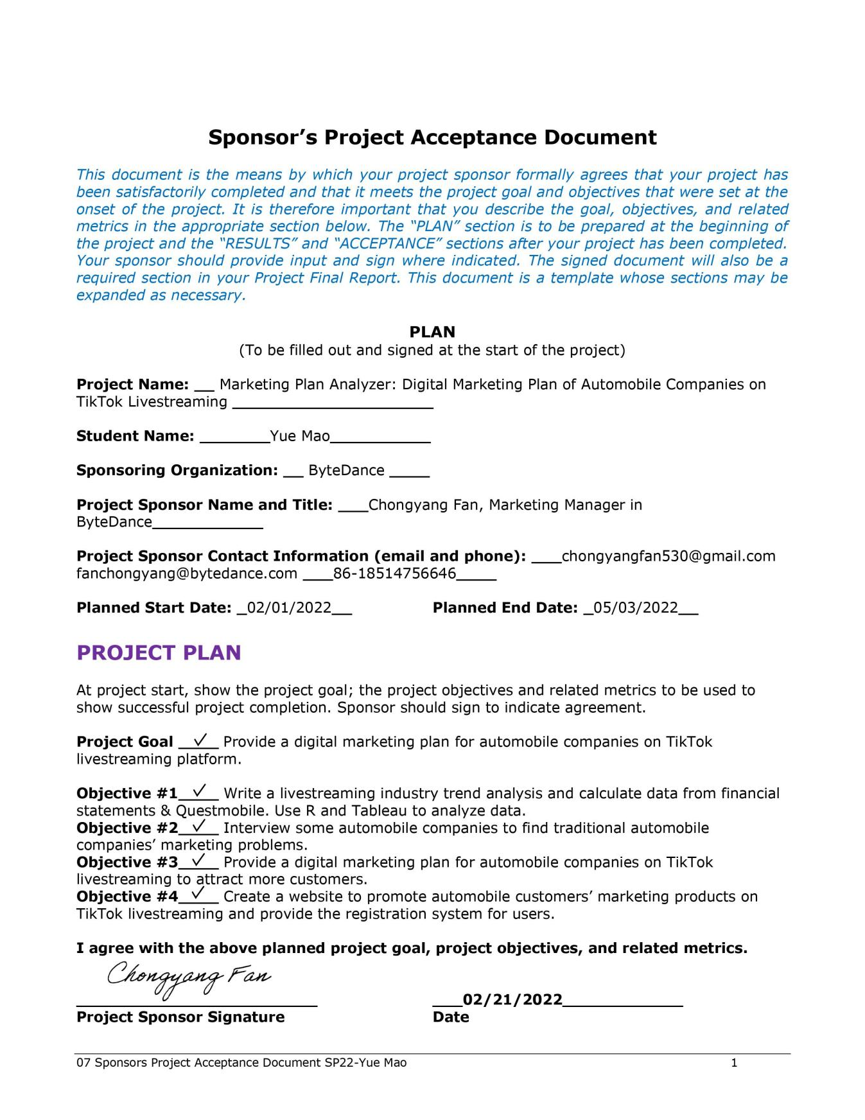

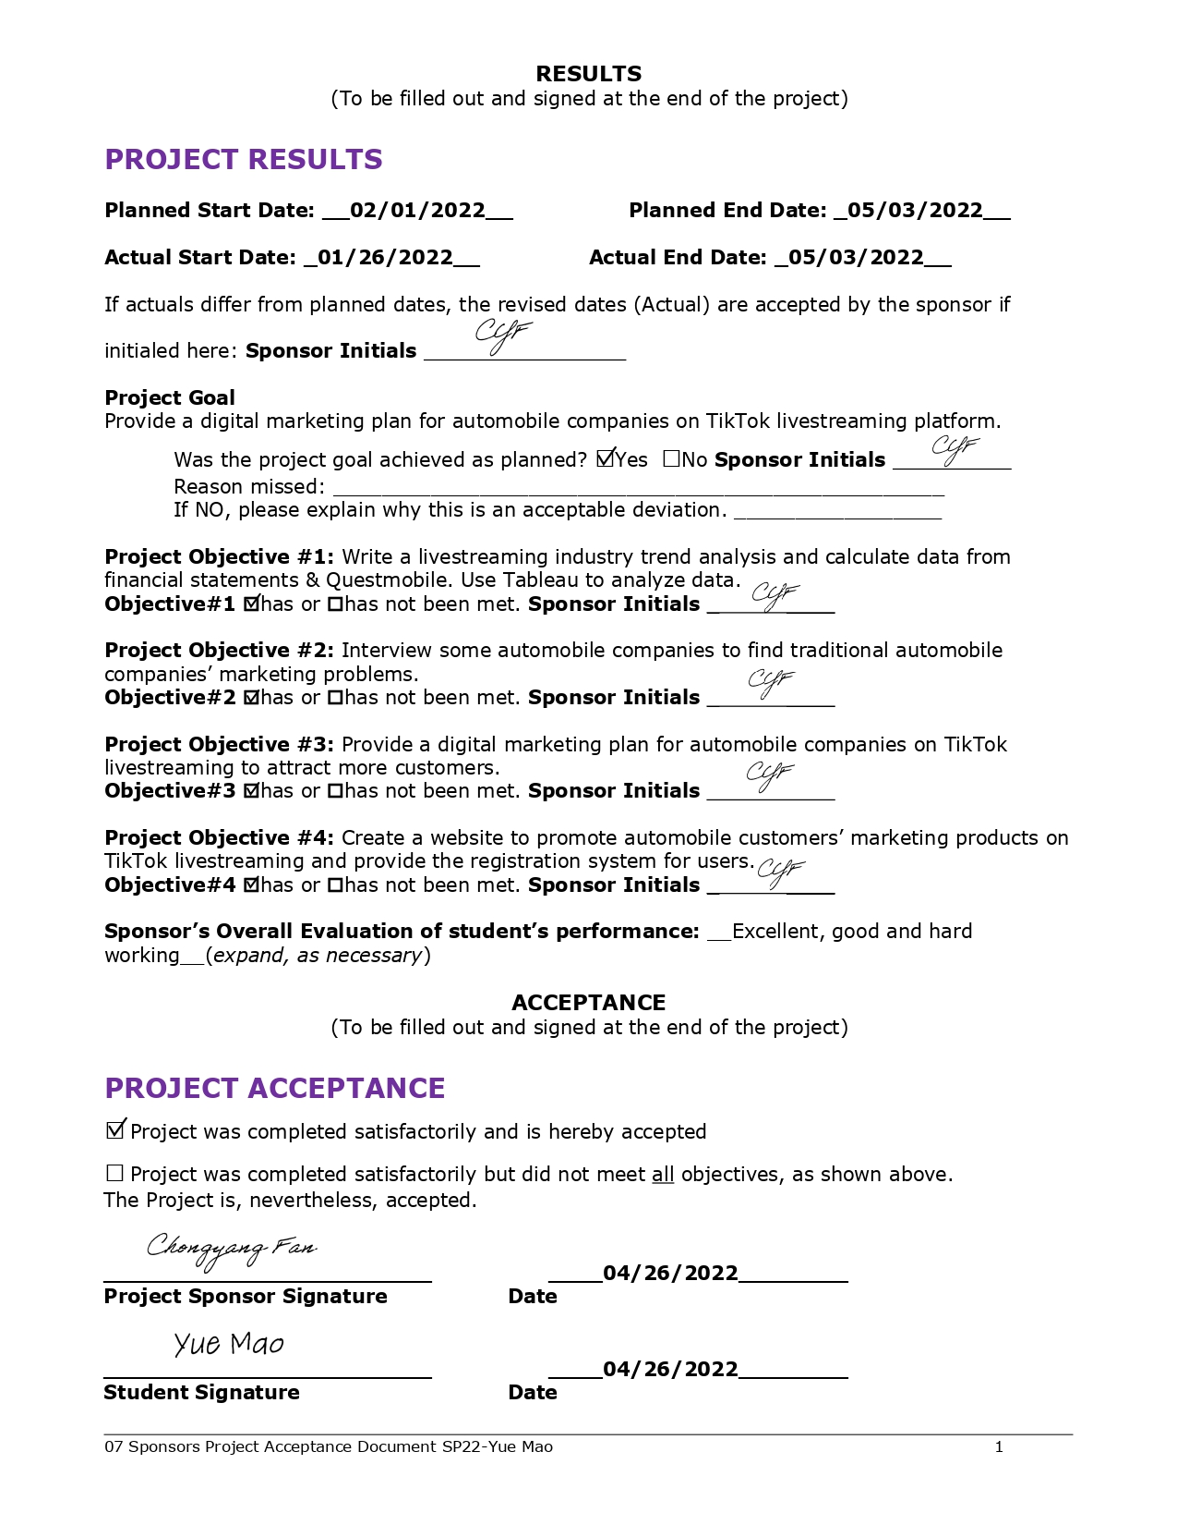

# Appendix B - Project Sponsor Agreement

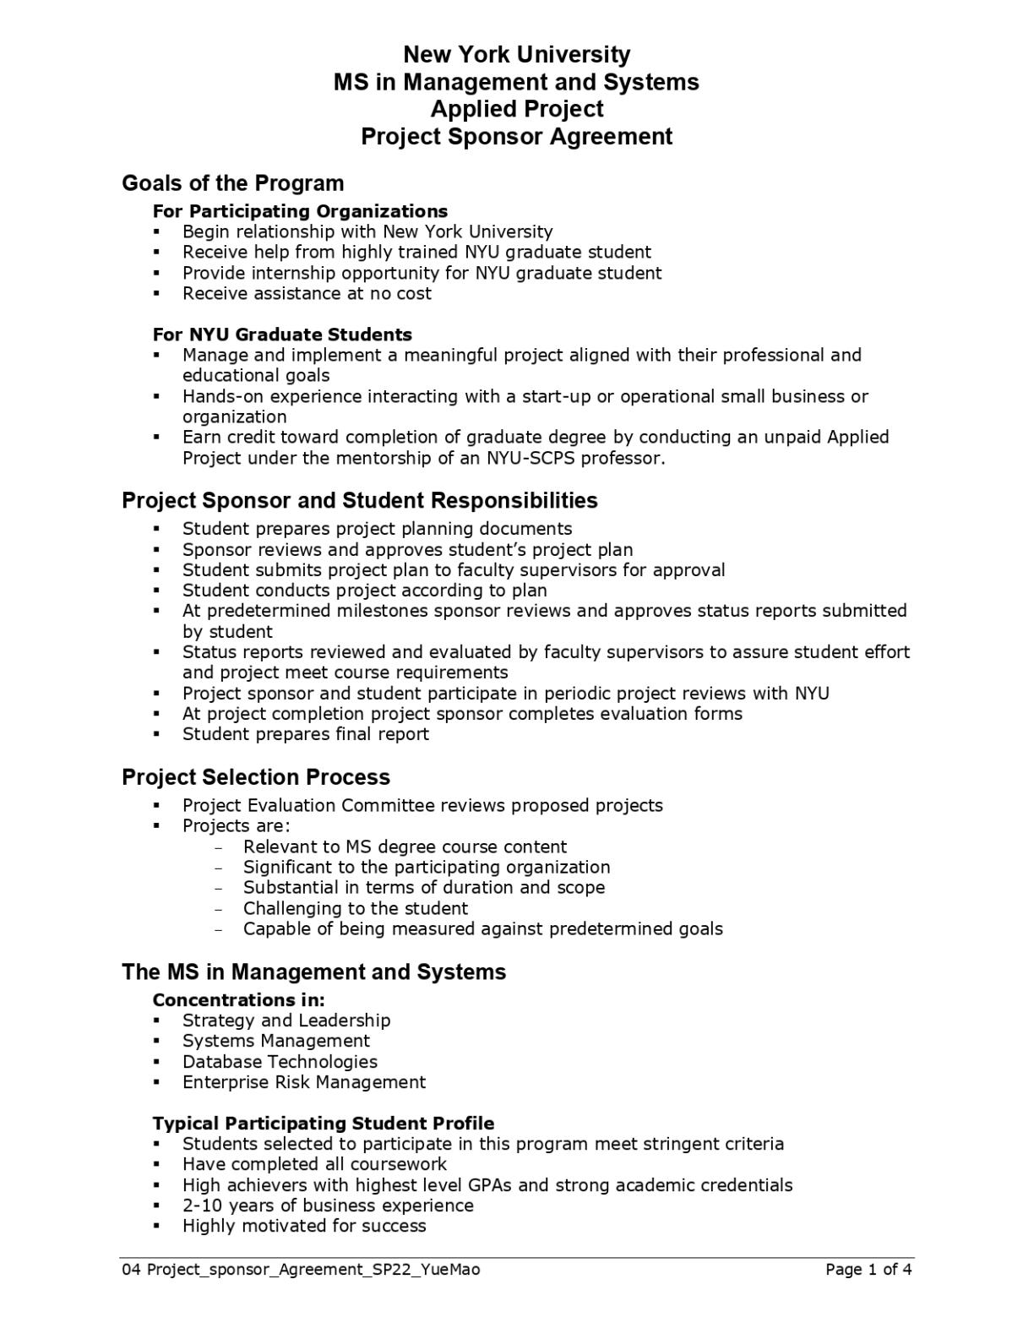

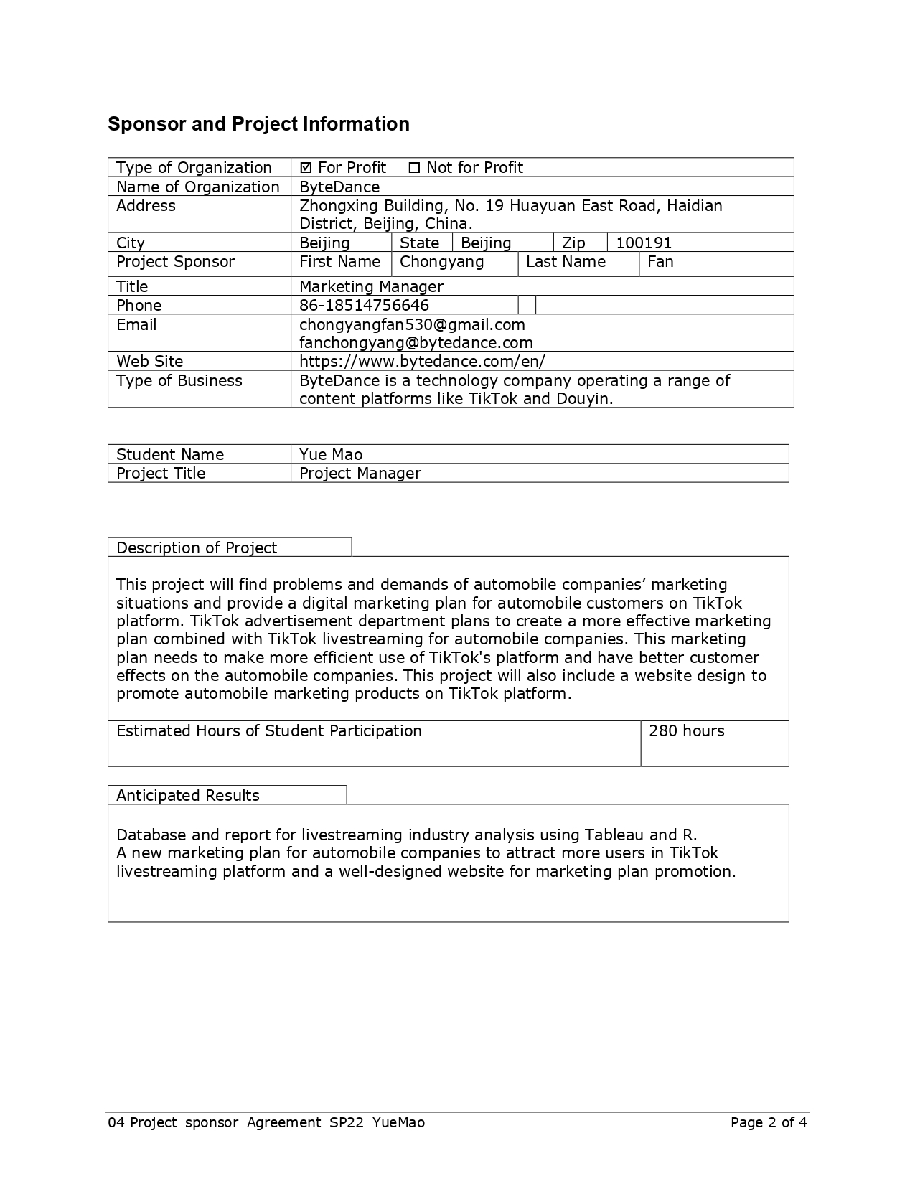

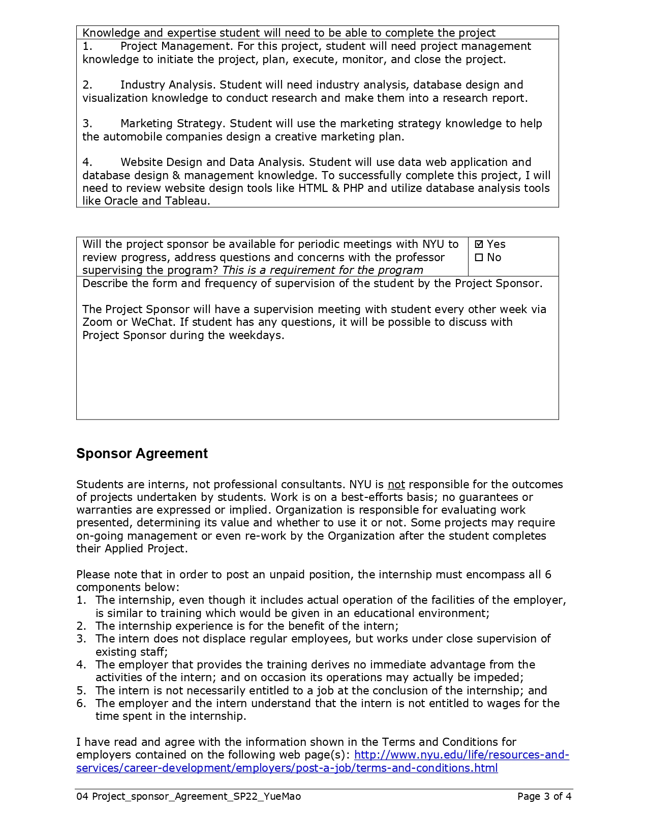

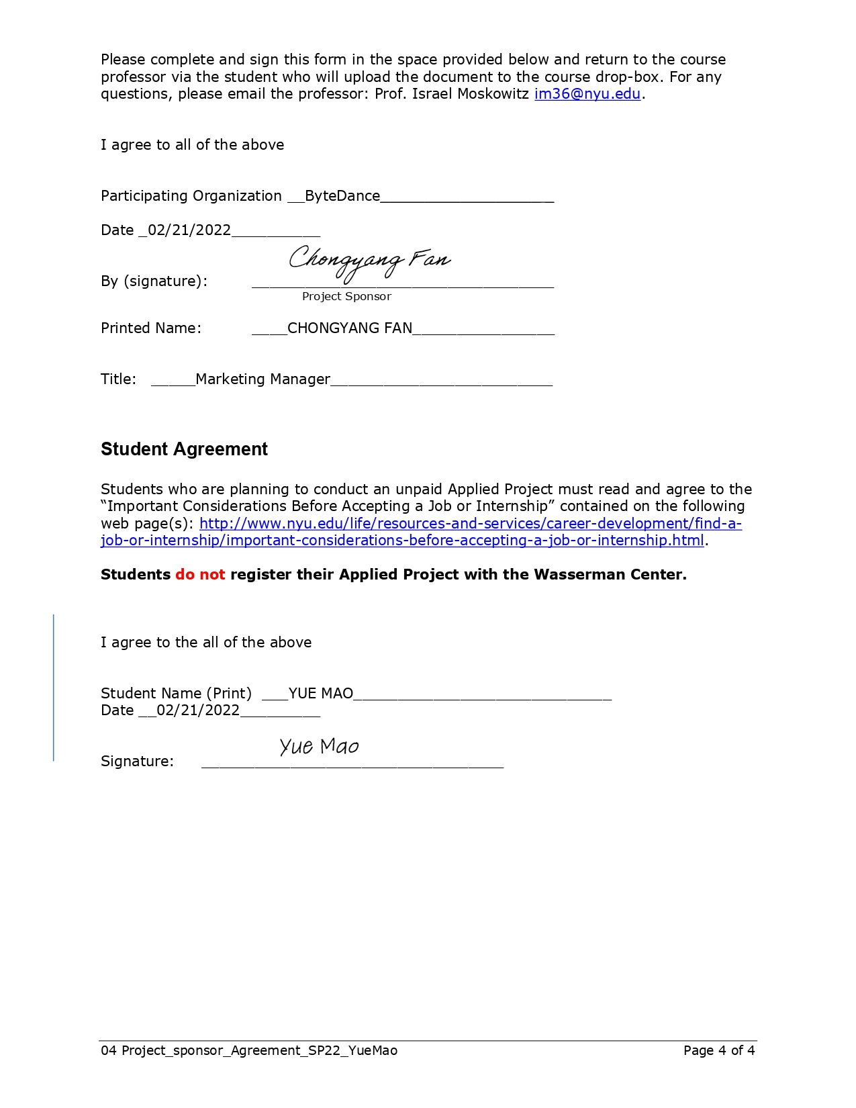

# Appendix C - Project Charter

**Project Charter**

Project Manager: Yue Mao

Sponsor: Chongyang Fan

Prepared by: Yue Mao

Name and Location of Client Organization: ByteDance, Zhongxing Building, No. 19 Huayuan East Road, Haidian District, Beijing, China.

1. **Project Goal**

Traditional automobile companies are undergoing digital marketing transformation. This project will find problems and demands of automobile companies’ marketing situations and provide a digital marketing plan for automobile customers on TikTok platform. TikTok advertisement department plans to create a more effective marketing plan combined with TikTok livestreaming for automobile brand customers. This marketing plan needs to make more efficient use of TikTok livestreaming platform and have better customer effects on the automobile companies. This project will also include a website design for promoting automobile marketing products on TikTok livestreaming platform.

1. **Problem/Opportunity Definition**

Nowadays, the traditional marketing mode of automobile companies has certain problems. Some existing marketing methods have a limited number of customers and cannot reach more users. The TikTok platform has those automobile customers in their marketing department. TikTok needs to help those automobile customers to find a new marketing plan. In this project, I will address a brand-new marketing plan for better customer growth to deal with automobile business marketing issues.

1. **Proposed Project Description**

First, I will compile an industry analysis to find the trend of main companies in livestreaming industry. During this analysis, the development trend of livestreaming industry and business performance in different companies will be clearly displayed using Tableau and R tools. After that, this project will interview representative automobile companies to find problems and demands in their traditional marketing strategies. The profile and current marketing problems of those typical automobile companies will be notified in this part. In addition, with the demands of automobile companies, this project will provide automobile companies a digital marketing plan on TikTok livestreaming platform. Finally, I will create a website to promote automobile marketing products in TikTok and provide the registration system for users.

1. **Project Sponsor(s)**

The project sponsor is ChongYang Fan, who is a marketing manager in TikTok advertisement department in ByteDance.

1. **Objectives**

Object 1 – Write a livestreaming industry trend analysis and calculate data from financial statements & Questmobile. Use R and Tableau to analyze data.

Measurement: Finish the livestreaming industry data analysis by the Mar 8th, 2022.

Object 2 – Contact with my sponsor and interview some automobile companies to find traditional automobile companies’ marketing problems.

Measurement: Finish the typical automobile companies’ marketing problems and demands report by Mar 25th, 2022.

Object 3 – Provide a digital marketing plan for automobile companies in TikTok live streaming to attract more customers.

Measurement: Deliver the digital marketing promotion plan by Apr 5th, 2022.

Object 4 - Create a website to promote automobile customers’ marketing products in TikTok livestreaming and provide the registration system for users.

Measurement: Deliver complete website and report accepted by client by May 3rd, 2022

1. **Project Selection & Ranking Criteria**

*(This section describes how this project was selected to be carried out as a project)*

Project benefit category:

|  |  |
| --- | --- |
|  | Compliance/Regulatory |
|  | Efficiency/Cost reduction |
| X | Revenue increase |

Portfolio fit and interdependencies

The automobile companies are main customer in my sponsor’s department, they have limitation in their traditional store sale methods. Those automobile companies are urgent to search for a method to expand their customer channels. It’s important to find an efficient project to increase automobile companies’ customers. After data tests on TikTok livestreaming, there are more than 10 million livestreaming views and hundreds of millions video viewers every day. More important, TikTok livestreaming enterprise account has been popular in customer companies. TikTok Livestreaming has become one of the most suitable channels for car viewing and inquiries. Therefore, this project is important and independent, not only for better use the viewers resources on TikTok livestreaming platform, but also help automobile companies to attract more customers and increase revenue.

Project urgency

This project is urgent and must be done over the next 6 months. Because our automotive company customers have yearly agreements with the sponsor's departments, it is necessary for us to provide marketing programs for automobile customers and see actual customer growth and revenue increase.

1. **Cost/Benefit Analysis**

Tangible Benefits

Benefit: This project will increase revenue in TikTok livestreaming department and automobile companies.

Value & Probability: This project will increase number of customers in automobile companies and improve sales volume.

Assumptions Driving Value: This project will achieve the ideal results and meet the revenue and commission of automobile companies.

Intangible Benefits

Benefit: This project will have more exposure of automobile companies and TikTok livestreaming platform.

Value & Probability: This project will promote the TikTok livestreaming platform to attract more companies to have their accounts.

Assumptions Driving Value: This project will improve the popularity and reputation of TikTok livestreaming platform and automobile companies.

Cost Categories

Internal Labor hours: This project will take 300 hours in total.

External costs: The website logo, interview survey fees and automobile companies’ costs will become the external costs.

Labor (consultants, contract labor): None

Equipment, hardware, or software: This project will use project manager’s laptop and live voice recorder as equipment.

List other costs such as travel & training: None

Financial Return

This project may have a financial return when the marketing plan achieves revenue increase for the automobile companies.

1. **Assumptions**
2. Project Manager is skilled in Excel, SQL, Tableau to analyze datasets during this project.

2. Project Manager is skilled in HTML and PHP to create the marketing plan promotion website.

1. Project Sponsor and Project Manager have regular meetings during the project schedule timeline.
2. The automobile companies’ interview could be performed regularly, and project related datasets are available.
3. **Scope**

Quality

The quality of this project will provide a complete marketing plan that rationally utilizes TikTok livestreaming user resources and suits the conditions of automobile companies.

The quality of this project will provide a usable web page showing the marketing plan and promotion products.

Time

This project has time constraints. The calendar dates of this project are from February 1st to May 3rd. The final due date of this project is May 3rd and there will be 300 hours allocated to this project.

Resource Allocation

The computer equipment is project manager’s computer, which is used for analysis and programming. The project manager and project sponsor are allocated to this project. The project manager is responsible for writing reports, data analysis and creating website. The project sponsor is responsible for consulting and providing project essential information.

Out of scope activities

This project will not be responsible for the revenue increase of automobile companies after marketing plan. This project only provides an effective marketing plan, but the extensions

market launch and revenue increase will not be tackled within this project.

Constraints

1. The data analysis and website creating expertise of project manager is entry level in this project.

2. The programming language will be used in this project are entry-level SQL, Tableau, and Excel analytical tools for data analysis.

The advanced UI/UX design will not be used in this project website due to the constraints of project manager’s technology level.

The amount of clients’ time is limited for meetings and questions is up to 6-10 times.

1. **Communications Plan**

1. Frequency: The project manager and the clients will have the meeting every other week.

2. Method: The communication plan method is using Zoom and WeChat meetings.

3. Content: The content of regular meeting is in several aspects. Firstly, this meeting will update the client the project status. Then, the project manager will discuss questions in project that have issues. During this meeting, the client will help project manager to have to resolve those issues in projects and provide related consulting information.

1. **Schedule Overview**

Project Start Date: February 1st, 2022

Estimated Project Completion Date: May 3rd, 2022

Major Milestones:

There are four major milestones in this project.

The first milestone is the completion of livestreaming industry analysis. This part needs data analysis and large amount of literature reviews. A deeply industry analysis is the completion evaluation for this milestone.

The second milestone is the completion of interviews. In this part, the project sponsor and project manager will have some interviews with automobile companies. By finishing interviews and collecting interview data, this milestone will be finish.

The third milestone is providing the digital marketing plan and complete the analysis of this marketing plan. Finishing the marketing plan report will be one of the signals of complete this milestone.

The last milestone is the completion of a marketing plan promotion website. All the codes and website functions should be done to finish this milestone.

External Milestones Affecting the Project: None

1. **Impact of Late Delivery**

For client, the late delivery of project will affect the client and automobile companies to meet their results on time as they negotiated before. This late delivery will have an impact on their next step plan. For personal, the late delivery will affect project manager’s capstone grades in this course.

1. **Resources Required**

Personnel: Yue Mao

|  |  |  |  |
| --- | --- | --- | --- |
| Role | Responsibilities | Duration of work | Qualifications needed |
| Project Manager | Determine all the project goals and project charts | From January 27th to May 3rd. | Project management training |
| Project Analyst | Writing project report, analyzing data, and creating website. | From January 27th to May 3rd. | Project Analyst need to know Excel, SQL, and Tableau for data analysis. |

Facilities, Software, Hardware, and other Resources

This project will need project manager’s computer, and computer programs including analytical tools like Microsoft Excel and Tableau, programs like Oracle SQL Developer, PHP and HTML.

Procedures/ Methodology

This project will create a marketing plan and website. The standard procedures of marketing plan including marketing goals, conducting market research, analyzing the competitor, identifying target audience, determining a budget, developing specific marketing strategies. The standard methodology in creating marketing plan including SWOT Analysis and Porter Five Forces Model.

The procedures of creating a website including registering domain name, determining company information, preparing website contents, and writing website code. Some standard methodology in creating this website including Waterfall and Agile software development cycle.

1. **Project Plan, Gantt**

This part will be referred to Gantt chart attached.

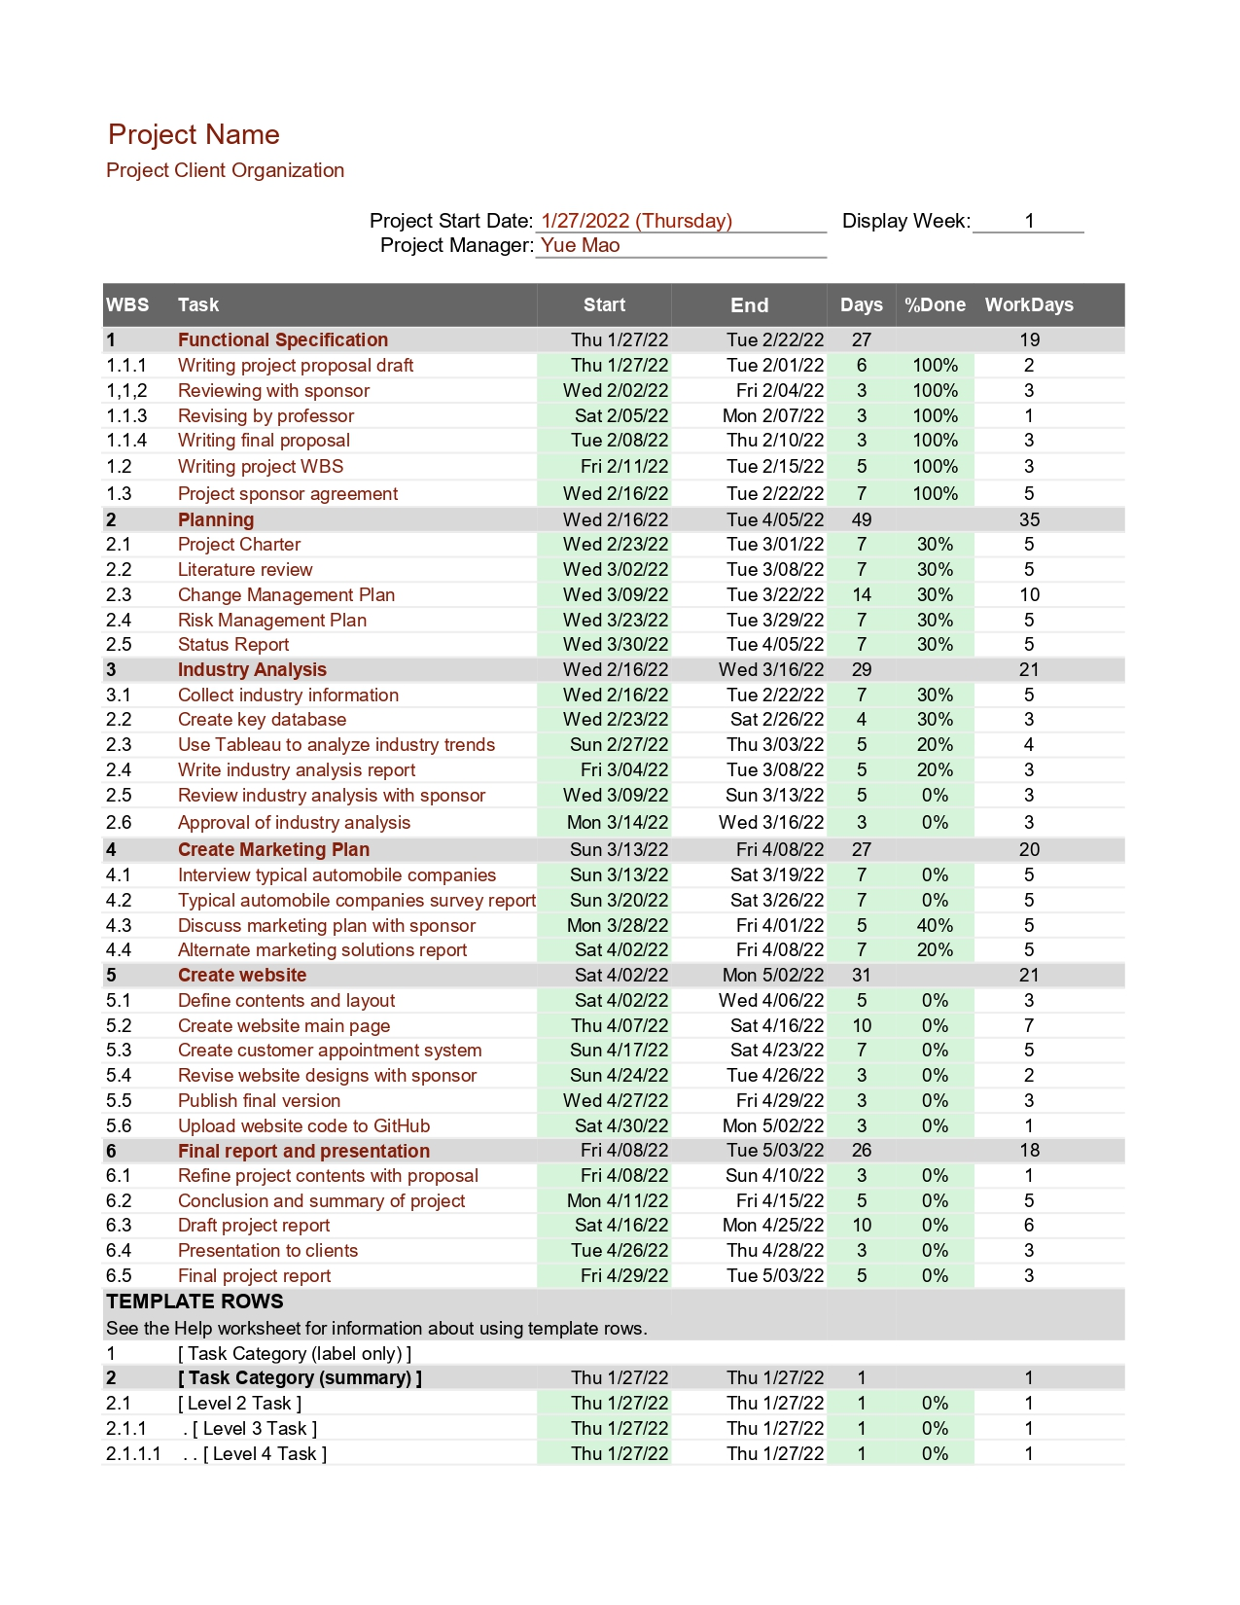

1. **Project Evaluation**
2. Project schedule

This project will meet the milestone deadline and the final due date. The client and project sponsor will sign the project completion document, project acceptance document before the due date to make sure this project will be delivered on time.

1. Project weekly status report and dashboard

The tool for project weekly status is Gantt chart. In the Gantt chart, there are milestones and timeline to put in. The project manager will keep the Gantt chart updated to clients. This Gantt chart will help clients know the project weekly status and where the project is on time. Once project manager completes each milestone and task the Gantt chart will show completion.

1. Project communication plan, issues log, risk register

The communication plan is weekly meetings with clients about the project progress and project plan in the next steps. The project manager will give client a project status formula, which will tell them what the project did in the past week, what is working on now and what will do in the future. The project required to fill the status form out and get assigned by client that he agrees the level of progress.

1. Project status reports

This project will do the project status reports and weekly meetings. The project report is in the middle of project. This report will respect all the milestones and tasks. Also, this report will confirm the project is on the right track and it will be complete on time.

# Appendix D - Project Plan

1. Functional Specification

1.1 Writing project proposal

1.1.2 Reviewing with sponsor

1.1.3 Revising by professor

1.1.4 Writing final proposal

1.2 Writing project Work Breakdown Structure

1.3 Project sponsor agreement

2. Planning

2.1 Project Charter

2.2 Literature review

2.3 Change Management Plan

2.4 Risk Management Plan

2.5 Status Report

3. Industry Analysis

3.1 Collect industry information

3.2 Create key database

3.3 Use Tableau to analyze industry trends

3.4 Write industry analysis report

3.5 Review industry analysis with sponsor

3.6 Approval of industry analysis

4. Create Marketing Plan

4.1 Interview typical automobile companies

4.2 Typical automobile companies survey report

4.3 Discuss marketing plan with sponsor

4.4 Alternate marketing solutions report

5. Create website

5.1 Define contents and layout

5.2 Create website main page

5.3 Create customer appointment system

5.4 Revise website designs with sponsor

5.5 Publish final version

5.6 Upload website code to GitHub

6. Final report and presentation

6.1 Refine project contents with proposal

6.2 Conclusion and summary of project

6.3 Draft project report

6.4 Presentation to clients

6.5 Final project report

**Work Breakdown Structure**



# Appendix E - Risk Management Plan

**Project**

This project name is Marketing Plan Analyzer: Digital Marketing Plan of Automobile Companies on TikTok Livestreaming. This project will find problems and demands of automobile companies’ marketing situations and provide a digital marketing plan for automobile companies on TikTok platform. The project will also include a website design for promoting automobile marketing products on TikTok platform.

**Risks**

|  |  |  |  |
| --- | --- | --- | --- |
| **Number** | **Risk** | **Probability Score (1,2 or 3)** | **Impact Score (1,2 or 3)** |
| 1 | Not completing the project on time | 1 | 3 |
| 2 | Project budget decrease and affect website quality | 2 | 2 |
| 3 | Project quality does not meet clients’ requirements before deadline | 2 | 3 |
| 4 | Project have difficulty in finding sufficient data during industry research | 3 | 2 |
| 5 | Lack of website design skills | 3 | 3 |
| 6 | Unforeseen automobile companies refusing to receive interviews | 3 | 1 |

**Risk Matrix**

|  |  |  |  |  |
| --- | --- | --- | --- | --- |
|  | RISK (exposure) | | | |
| Probability (of occurrence) |  | 1.Slight | 2. Moderate | 3. High |
| 1. Very Unlikely |  |  | 1 |
| 2. Possible |  | 2 | 3 |
| 3. Expected | 6 | 4 | 5 |

**Contingency Plan**

|  |  |  |  |  |
| --- | --- | --- | --- | --- |
| **Risk** | **Description** | **Probability (1-3)** | **Exposure (1-3)** | **Contingency Plan** |
| **1** | Lack of website design skills | 3 | 3 | Project Manager need to improve website design skills by learning resources and receive website design advice from project sponsor in every project meeting. |
| **2** | Project quality does not meet clients’ requirements before deadline | 2 | 3 | Project Manager need to update project progress with clients every week, follow up clients’ requirements and receive project improvement suggestions in project meetings. |
| **3** | Project have difficulty in finding sufficient data during industry research | 3 | 2 | This project will select industry research in existing database fields, find multiple datasets and related literature or create surveys to collect data in interviews. |

**RACI Matrix**



# Appendix F - Status Report

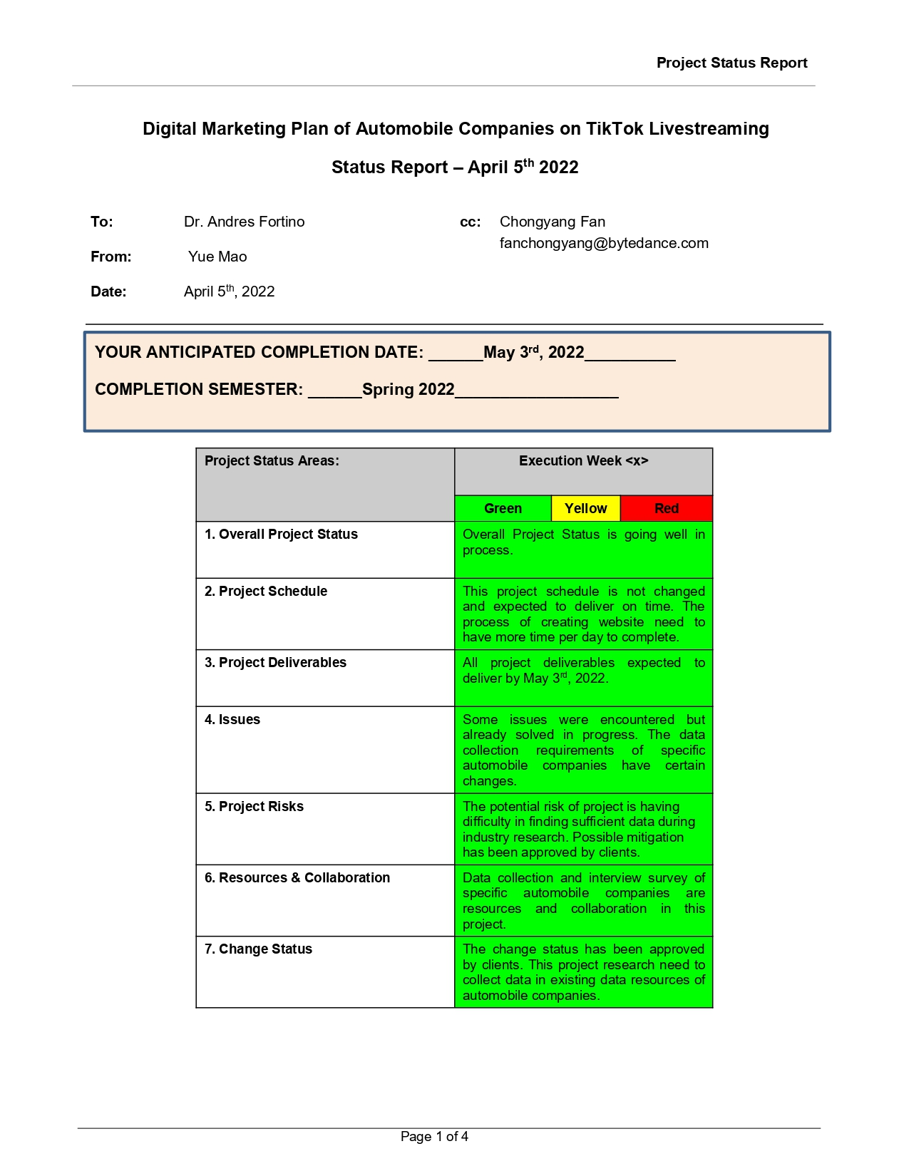

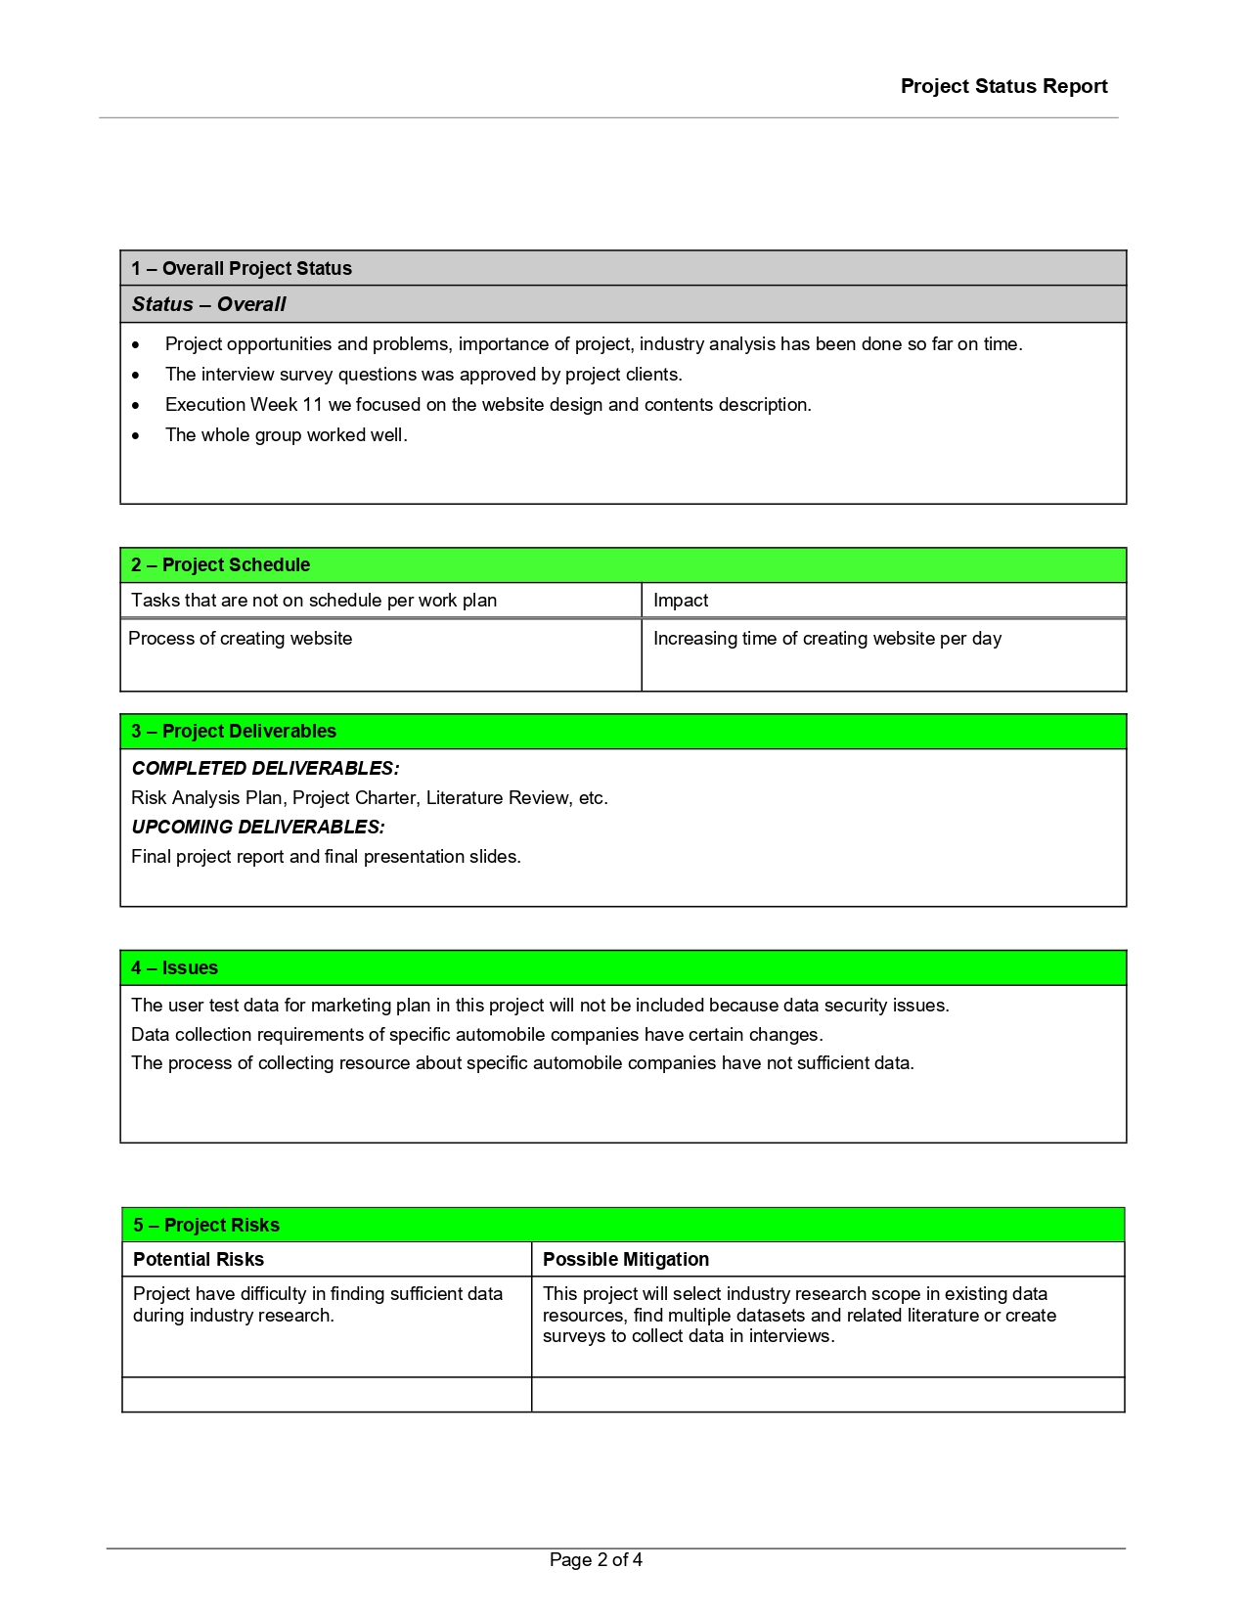

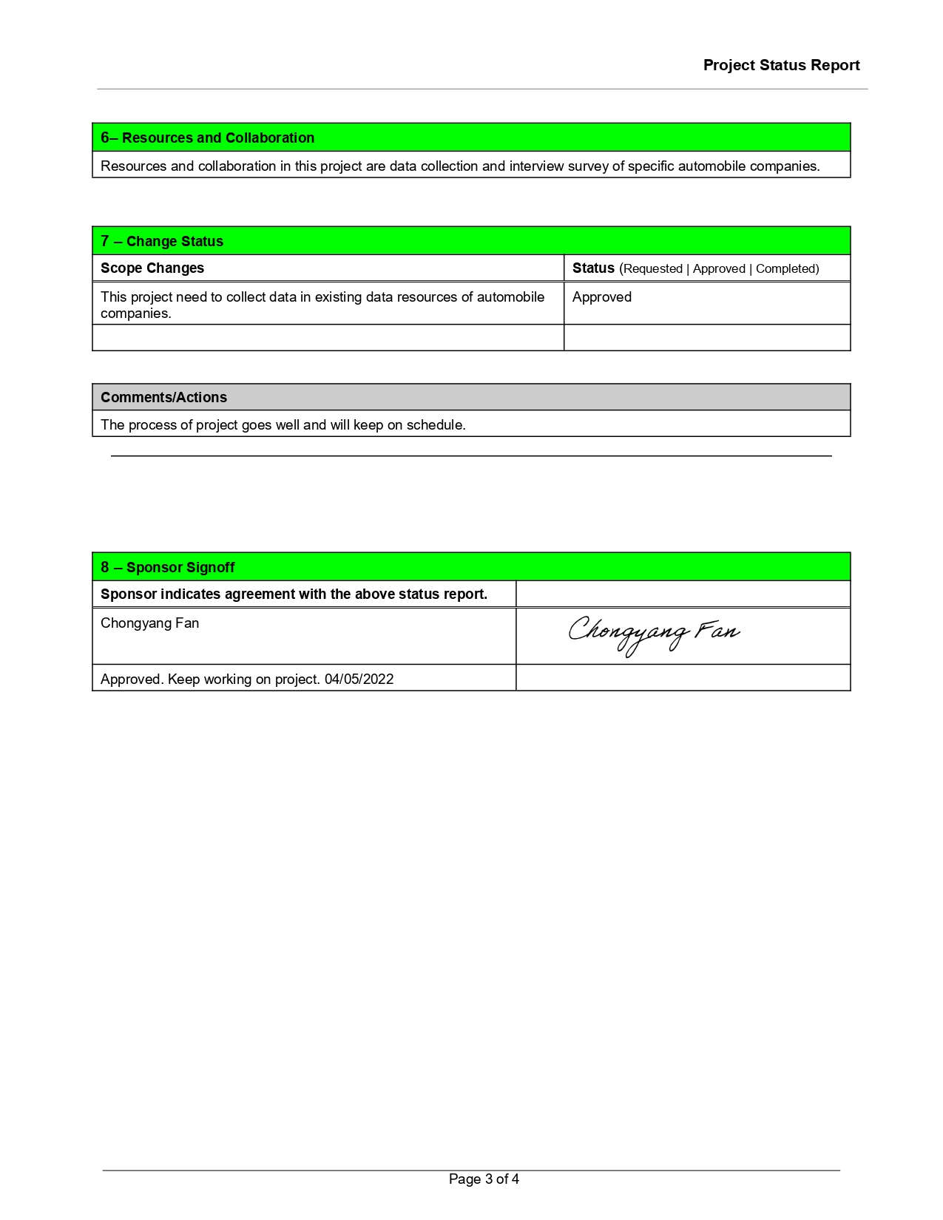

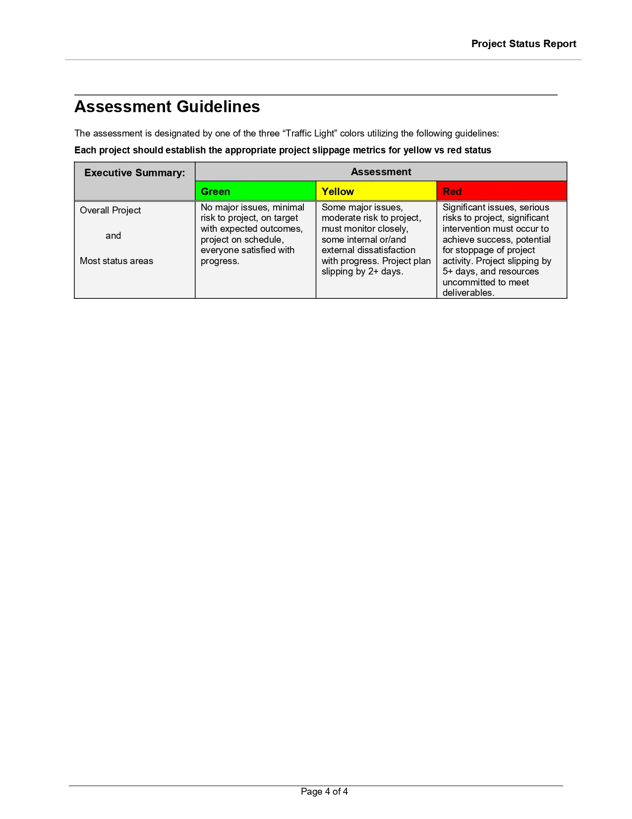

# PROJECT CHANGE MANAGEMENT PLAN

|  |  |
| --- | --- |
| **Project Name:** | Marketing Plan Analyzer: Digital Marketing Plan of Automobile Companies on TikTok Livestreaming |
| **Prepared by:** | **Yue Mao** |
| **Date (MM/DD/YYYY):** | **03/22/2022** |

| 1. Purpose | |
| --- | --- |
| *The purpose of this* Change Management Plan *is to:* | |
| 1. Ensure that all changes to the project are reviewed and approved in advance. 2. All changes are coordinated across the entire project and adjust to effective controls. 3. All stakeholders and Project Team are notified of approved changes to the project. | |
| *All project Change Requests (CR) must be submitted in written form using the Change Request Form provided.* | **Link_To_Project Change Request Form** |
| *The project team should keep a log of all Change Requests.* | **Link_To_Project Change Request Log** |

| 2. Goals |
| --- |
| *The goals of this* Change Management Plan *are to:* |
| 1. Give due consideration to all requests for changes. 2. Identify, evaluate, approve, and track changes through start to completion. 3. Define change request process of different impact assessment levels. 4. Modify Project Plans to reflect the impact of the changes requested. 5. Bring the appropriate parties (depending on the nature of the requested change) into the discussion and maintain the effective transparency of change requests. 6. Negotiate change requests and communicate recommendations to Project Team. |

| 3. Responsibilities | |
| --- | --- |
| *Those responsible for Change Management* | *Their Responsibilities* |
| 1. Project Manager (with the Project Sponsor) | Developing and signing the Change Management Plan. Assessing and facilitating the change management process. |
| 1. Project Manager | Conducting reviews of all change management activities with project sponsor and clients on a periodic basis. Writing Change Request (CR) in project change management process and updating activities according to feedback. |
| 1. Project Sponsor | Reviewing all project change activities with project manager and assess appropriate project change plans for approval. |
| 1. Project Clients | Assessing the impact of project change management activities on the project outcome and providing approval of project change requests. |
| 1. The Executive Committee | Ensuring that adequate resources and funding are available to support execution of the Change Management Plan.  Approving Change Management Plan and ensuring that theChange Management Plan is implemented. |

| 4. Process | | |
| --- | --- | --- |
|  | | |
| The Change Management process occurs in eight steps:   1. Identify potential project changes. 2. Communicate potential changes with Project Sponsor. 3. Submit written Change Request (CR) according to communication results. 4. Review Change Request (CR) and approve or reject for further analysis. 5. If approved, perform analysis and develop recommendation for changes. 6. Accept or reject the recommendation and modify documents. 7. If accepted, update project reports and re-plan project schedule. 8. Notify all stakeholders of the changes. | | |
| In practice the Change Request process is a bit more complex. The following describes the change control process in detail: | | |
| 1. **Any stakeholder can request or identify a change. He/she uses a *Change Request Form* to document the time of the change request.** | | |
| 1. **The completed form is sent to Project Manager of the Project Team who enters the CR into the *Project Change Request Log*.** | | **Link_To_Project Change Request Log** |
| 1. **CRs are reviewed daily by the Project Team and assigned one four possible outcomes:** | | |
| 1. *Reject:* | 1. Notice is sent to the submitter. 2. Submitter may appeal (which sends the matter to the Project Team). 3. Project Team reviews the CR at its next meeting. | |
| 1. *Defer to a date:* | 1. Project Team is scheduled to consider the CR on a given date. 2. Notice is sent to the submitter. 3. Submitter may appeal (which sends the matter to the Project Team). 4. Project Team reviews the CR at their next meeting. | |
| 1. *Accept for analysis immediately (e.g., emergency):* | 1. An analyst is assigned, and impact analysis begins. 2. Project Team reviews the analysis at its next meeting. 3. Project Team is notified the CR and take consideration. | |
| 1. *Accept for consideration by the project team:* | 1. Project Team reviews the CR at its next meeting. | |
| 1. **All new pending CRs are reviewed at the Project Team meeting. Possible outcomes:** | | |
| 1. *Reject:* | 1. Notice is sent to the submitter. 2. Submitter may appeal (which sends the matter to the Project Sponsor, and possibly to the Executive Committee). 3. Executive Committee have final review and decision of CRs. | |
| 1. *Defer to a date:* | 1. Project Team is scheduled to consider the CR on a given date. 2. Notice is sent to the submitter. 3. Submitter may appeal (which sends the matter to the Project Team). 4. Project Team reviews the CR at their next meeting. | |
| 1. *Accept for analysis:* | 1. An analyst is assigned and impact analysis begins 2. Project Team reviews the analysis at its next meeting. | |
| 1. **Once the analysis is complete, the Project Team reviews the results.[1] Possible outcomes:** | | |
| 1. *Reject:* | 1. Notice is sent to the submitter. 2. The submitter may appeal which solves the matter to the Project Sponsor (and possibly to the Executive Committee). 3. Executive Committee have final review and decisions. | |
| 1. *Accept:* | 1. Project Team accepts the analyst’s recommendation. 2. Notice is sent to Project Sponsor as follows: 3. Low-impact CR – Information only, no action required. 4. Medium-impact CR – Sponsor review requested; no other action required. 5. High-impact CR – Sponsor approval required. | |
| 1. *Return for further analysis:* | Project Team has questions or suggestions that are sent back to the analyst for further consideration. | |
| 1. **Accepted CRs are forwarded to the Project Sponsor for review of recommendations. Possible outcomes:** | | |
| 1. *Reject:* | 1. Notice is sent to the submitter. 2. Submitter may appeal to the Project Sponsor and Executive Committee. 3. Project Sponsor and Executive Committee review for final consideration. | |
| 1. *Accept:* | 1. Notice is sent to the submitter. 2. The CRs are forwarded to Project Sponsor for review of recommendations. 3. Project Team have re-plan meetings. 4. Project Manager modifies relevant project documents. 5. Project Team acts on the new plan. | |
| 1. *Return for further analysis:* | 1. The Sponsor has questions or suggestions that are sent back to the analyst for further consideration. 2. Notice is sent to the submitter. 3. Analyst’s recommendations are reviewed by Project Team (return to *Step 5*). | |

| 5. Notes on the Change Control Process | | |
| --- | --- | --- |
| *<Modify Sections 3 and 5 to meet the needs of your project.>* | | |
| 1. **A Change Request is:** | | |
| 1. Included in the project only when both Sponsor and Project Team agree on a recommended action. | | |
| 1. **The CR may be:** | | |
| 1. *Low-impact* – Has no material effect on cost or schedule. Quality is not impaired. 2. *Medium-impact* – Moderate impact on cost or schedule, or no impact on cost or schedule but quality is impaired. If impact is negative, Sponsor review and approval is required. 3. High-impact – Significant impact on cost, schedule, or quality. If impact is negative, Project Sponsor, Executive Committee review and approval is required. | | |
| 1. **For this project:** | | |
| 1. *Moderate-impact* – Fewer than *5 business* days change in schedule; less than $*100* change in budget; one or more major use cases materially degraded. 2. *High-impact* – More than *10 business* days change in schedule; more than $*100* change in budget; one or more major use cases lost. | | |
| 1. **All project changes will require some degree of update to project documents:** | | |
| 1. *Low-impact*– Changes likely require update only to requirements and specifications documents. 2. *Moderate- or high-impact* – depending on the type of change, the following documents (at a minimum) must be reviewed and may require update: | | |
| *Type of Change:* | *Documents to Review (and update as needed):* | |
| 1. Scope | 1. Scope Statement and WBS 2. Budget 3. Project Schedule 4. Resource Plan 5. Risk Management Plan 6. Requirements 7. Project Proposal 8. Specifications | |
| 1. Schedule | 1. Project Schedule 2. Work Breakdown Structure 3. Budget 4. Resource Plan 5. Risk Management Plan | |
| 1. Budget | 1. Budget 2. Project Schedule 3. Resource Plan 4. Risk Management Plan | |
| 1. Quality | 1. Budget 2. Project Schedule 3. Resource Plan 4. Risk Management Plan 5. Quality Plan 6. Requirements 7. Project Final Report | |
| 1. **Project documents:** | | |
| Whenever changes are made to project documents, the version history is updated in the document and prior versions are maintained in an archive. Edit access to project documents is limited to the Project Manager, Project Sponsor and Clients in the Project Team. | | |
| 1. For this project, all electronic documents are kept in (select one of the following and describe it in the adjacent space provided): | | |
| **[ ]** Version Control System: | |  |
| **[ ]** Central storage available to the Project Team: | | All the electronic documents, including project proposal, research papers, project change management plan and other documents are kept in the project cloud storage. All the documents are available to modified and reviewed by the Project Team. |
| **[ ]** Other: | |  |
| 1. For this project, all paper documents are kept in (select one of the following and describe it in the adjacent space provided): | | |
| **[ ]** Project file maintained by the Project Manager: | | All the electronic documents, including project proposal, research papers, project change management plan and other documents are kept in the Project Manager’s laptop. All the documents are maintained by Project Manager in a regular basis. |
| **[ ]** Other: | |  |
| 1. The following individuals have edit access to project documents: | | |
| *Role* | | *Documents* |
| 1. Project Manager | | 1. All current documents 2. Project archive 3. Project website code 4. Project Proposal and Final Reports 5. Research Papers |
| 1. Project Sponsor | | 1. Project Proposal 2. Project Change Management Plan |
| 1. Project Clients | | 1. Project Proposal |
|  | | 1. Final Project Presentation and Reports |
|  | |  |

| 6. Project Change Management Plan / Signatures | | | | |
| --- | --- | --- | --- | --- |
| **Project Name:** | Marketing Plan Analyzer: Digital Marketing Plan of Automobile Companies on TikTok Livestreaming | | | |
| **Project Manager:** | Yue Mao | | | |
| *I have reviewed the information contained in this* Project Change Management Plan *and agree:* | | | | |
| Name | | Role | Signature | Date **(MM/DD/YYYY)** |
| Yue Mao | | Project Manager |  | 03/22/2022 |
| Chongyang Fan | | Project Sponsor |  | 03/22/2022 |
|  | |  |  |  |
|  | |  |  |  |
|  | |  |  |  |
|  | |  |  |  |

*The signatures above indicate an understanding of the purpose and content of this document by those signing it. By signing this document, they agree to this as the formal* Project Change Management Plan*.*

# Appendix G - Annotated Bibliography

1. Si, R. (2021). China Livestreaming E-commerce Industry Insights. *Palgrave Macmillan, Singapore.* 1-105.

*This book analyzes multiple aspects of the Chinese livestreaming e-commerce industry, including its development and evolution, macro environment, market landscape, platforms, streamer structure trends, influencers, production, and explosive marketing methods, MCN operations, risk assessment and policy management. It not only describes the highly developed state of the industry in China and how it has advanced further because of COVID lockdowns, but also focuses on the problems of livestreaming e-commerce and proposes solutions and development strategies. Investigating the development trends, the book also discusses how far livestreaming e-commerce can go during the wind-up period…*

**In this book, it describes Chinese livestreaming e-commerce industry, which is the same with my applied project topic main industry direction. The reason why I want to choose this literature is that the industry analysis part in this paper, like impact of livestreaming rising in different aspects, especially provides some short video platform examples including TikTok and Kwai. This book provides information related to my livestreaming industry analysis part.**

1. Lu, Z., Xia, H., Heo, S., & Wigdor, D. (2018). You Watch, You Give, and You Engage: A Study of Live Streaming Practices in China. *Proceedings of the 2018 CHI Conference on Human Factors in Computing Systems,* 21-26.

*Despite gaining traction in North America, live streaming has not reached the popularity it has in China, where live- streaming has a tremendous impact on the social behaviors of users. To better understand this socio-technological phenomenon, we conducted a mixed methods study of live streaming practices in China. We present the results of an online survey of 527 live streaming users, focusing on their broadcasting or viewing practices and the experiences they find most engaging. We also interviewed 14 active users to explore their motivations and experiences. Our data revealed the different categories of content that was broadcasted and how varying aspects of this content engaged viewers. We also gained insight into the role reward systems and fan group-chat play in engaging users, while also finding evidence that both viewers and streamers desire deeper channels and mechanisms for interaction in addition to the commenting, gifting, and fan groups that are available today…*

**This literature provides review of the opportunities and challenges of live streaming, and the user engagement in livestreaming. This article empirically examined user’s live streaming practices in China. More importantly, this article has interview data collection and surveys, which is related to the interview methods that will provide in my paper.**

1. Lin, J., & Lu, Z. (2017). The Rise and Proliferation of Live-Streaming in China: Insights and Lessons. *Communications in Computer and Information Science, 714*(7), 632-637.

*The $5 billion dollar live streaming industry has a tremendous impact on the social behaviors of internet users in China. However, despite early appearance of the technology in the North America, live streaming has yet to reach the level it has in China. Using observations from the rise and proliferation of live streaming services in China, we identify some culture and social insights about the phenomenon as well as some lessons that we can apply to North America…*

**This article wrote the rise insight of livestreaming and effects on Mainstream Media. There also has been research in other related fields, like mobile live video chatting, online video sharing, and specialized video streaming services. The reason why I choose this article is that the analysis of this article is very close to the real situation of China's livestreaming market and has detailed charts for my paper to learn from.**

1. Cao, X. (2019). Bullet Screens (Danmu): Texting, Online Streaming, and the Spectacle of Social Inequality on Chinese Social Networks. *Theory, Culture & Society 38*(3), 29-49.

*For theorists interested in screen cultures and the digital economy, looking beyond Facebook and YouTube prompts a more refined conceptualization of participation and monetization on social networks. This paper examines YY as representative of Chinese platforms that monetize spectacles of social inequality. I first discuss why these financially successful platforms have eluded the attention of media and cultural critics, and then explain how these social network platforms blend subversive texting with streaming through a format called ‘bullet screen’. This format collapses social inequality into a spectacle of money flowing and vanishing on screen. This investigation contributes to the theoretical discussion of mixed semiotics, reorients several Marxian neologisms and explains what texting means on screen in both semiotic and economic terms…*

**This literature deeply analyzes what drives the socially influential and financially successful streaming platforms. Also, this article analyzes new business models and the methods that users have payments in livestreaming. The reason why I choose this literature is that those livestreaming business modes are related to what my sponsor’s department used in projects.**

1. Hou, F., Guan, Z., Li,B ., & Chong, L. (2019). Factors influencing people’s continuous watching intention and consumption intention in live streaming Evidence from China. *Internet Research, 30*(1), 141-163.

*The purpose of this paper is to investigate what factors can affect people’s continuous watching and consumption intentions in live streaming. This research conducted a mixed-methods study. The semi-structured interviews were deployed to develop a research model and a live streaming typology. A survey was then used for quantitative assessment of the research model. Survey data were analyzed using partial least squares-structural equation modeling. The results suggest that sex and humor appeals, social status display and interactivity play considerable roles in the viewer’s behavioral intentions in live streaming and their effects vary across different live streaming types. Research limitations/implications – This research is conducted in the Chinese context. Future research can test the research model in other cultural contexts. This study can also be extended by incorporating the roles of viewer gender and price sensitivity in the future…*

**This literature analyzes global live streaming markets, trends, and challenges, which has profound livestreaming industry analysis with data support. This article figures out important factors that may affect livestreaming watching intention, like social status display, humor appeal and sex appeal. The reason why I choose this article is that important factors in this article could provide a comprehensive foundation for my livestreaming user analysis.**

1. Katrin, S. (2016). Information Behavior on Social Live Streaming Services. *Journal of Information Science Theory and Practice.4*(2), 6-20.

*In the last few years, a new type of synchronous social networking services (SNSs) has emerged—social live streaming services (SLSSs). Studying SLSSs is a new and exciting research field in information science. What information behaviors do users of live streaming platforms exhibit? In our empirical study we analyzed information production behavior (i.e., broadcasting) as well as information reception behavior (watching streams and commenting on them). We conducted two quantitative investigations, namely an online survey with YouNow users and observations of live streams on YouNow. YouNow is a service with video streams mostly made by adolescents for adolescents. YouNow users like to watch streams, to chat while watching, and to reward performers by using emoticons. While broadcasting, there is no anonymity. Synchronous SNSs remind us of the film The Truman Show, as anyone has the chance to consciously broadcast his or her own life real-time.*

**This literature has profound information behavior analysis of users on social livestreaming services. In this article, it has surveys for users to know their typical preferences like performer types and channel behavior. I choose this article because the survey part and industry analysis provide an outstanding example for me to study the user behavior, which helps my project provide more suitable marketing plan for customers.**

1. Gilbert, A.M. (2019). Strengthening Your Social Media Marketing with Live Streaming Video. *Smart Technologies and Innovation for a Sustainable Future. Advances in Science, Technology & Innovation,* 357-365.

*With more than 3 billion users worldwide, social media has transformed marketing; it offers individuals and organizations alike the ability to attract, convert, and transform consumers effectively and affordably. Mirroring the growth of social media are mobile devices: there are more than 5 million unique mobile users worldwide with nearly 2.8 million people accessing social media with mobile devices and 80% of worldwide internet users owning at least one smartphone. Mobile video is a particularly promising platform to communicate to consumers; 80% of Internet traffic will be video by 2019 and 74% of consumers are more likely to buy a product or service after watching a branded video. However, recorded video is costly and cumbersome to produce; live streaming video decreases costs while increasing customer engagement and enhancing influence. Recognizing that live streaming video can strengthen social media marketing strategies, this paper reviews the rise of social media, explains the role of live streaming video, previews live streaming video platforms, proposes live streaming video strategies, shares live streaming video survey results, and evaluates the impact of live streaming video…*

**This article provides both livestreaming industry analysis, including role of social media, user sizing, and livestreaming contents strategies. This article also provides surveys to investigate how different individuals and organizations market their products on live video streaming platforms. The reason why I choose this literature is that the surveys result in this article about the product marketing of different organizations on live streaming will provide a good study for my marketing plan in my project paper.**

1. Wongkitrungrueng, A., Dehouche, N., & Assarut, N. (2020). Livestreaming commerce from the sellers’ perspective: implications for online relationship marketing, *Journal of Marketing Management, 36*(5), 488-518.

*Live streaming has recently become a popular direct selling channel which offers small, self-employed seller’s unseen levels of consumer interaction and engagement. While the extant research focused on consumer motivation and intention to shop via live streaming, little is known from the seller’s perspective. Indeed, the potential advantages of live streaming commerce are accessible to everyone, but sellers experience different levels of success with this medium. Using a mixed quantitative and qualitative approach, this study analyses Facebook data of live streaming sellers to assess the nature and extent of engagement metrics, and delineate the dynamic, interactive live streaming sales process. We identify four sales approaches and twelve strategies adopted in acquiring and retaining customers. This typology of sales approach representing seller-focused antecedents is mapped against the relationship process and outcomes to provide a framework for understanding relationship mechanisms in live streaming commerce…*

**This article provides livestreaming commerce background, main livestreaming commerce channels. By analyzing typical livestreaming commerce channels in this article, especially sellers who share their personal lives with their customers and sell products via live streaming, this literature offers more detailed advice on a variety of sales approaches and strategies on live streaming. Those sales strategies and studies in this literature could provide a great reference for my marketing plan analysis in project.**

1. Suna,Y ., Shao, X., Li, X.T., Guo, Y., & Nie, K. (2019). How live streaming influences purchase intentions in social commerce: An IT affordance perspective. *Electronic Commerce Research and Applications,37*(1), 51-217.

*As a new form of social commerce, live streaming shopping is becoming increasingly popular among Chinese consumers, which has aroused great interest among practitioners and researchers. Building a theoretical model from the perspective of IT affordance, our study examines how live streaming influences social commerce customers’ purchase intentions in China. We empirically measure the model by surveying customers who have shopped via live streaming shopping platforms including Taobao.com, JD.com, Mogujie.com, and Sina Microblog. Our results show that visibility affordance, metavoicing affordance, and guidance shopping affordance can influence customer purchase intention through live streaming engagement. Our study highlights the importance of understanding the implications of IT affordance for social commerce…*

**This article provides livestreaming reviews, especially in social commerce, affordance lens and customer engagement. More importantly, this literature analyzes social commerce, purchase intentions from IT perspective. I choose this article because it helps me deeply analyze customer behavior and engagement and provides IT perspective to measure this topic in my paper.**

1. Wongkitrungruenga, A., & Assarutb, N. (2020). The role of live streaming in building consumer trust and engagement with social commerce sellers, *Journal of Business Research, 117*(1), 543-556.

*Live streaming services, whereby video is broadcast in real time, have been adopted by many small individual sellers as a direct selling tool. Drawing on literature in retailing, adoption behavior, and electronic commerce, this paper proposes a comprehensive framework with which to examine the relationships among customers' perceived value of live streaming, customer trust, and engagement. Symbolic value is found to have a direct and indirect effect via trust in sellers on customer engagement, while utilitarian and hedonic values are shown to affect customer engagement indirectly through customer trust in products and trust in sellers sequentially. Elucidating the role of live streaming in increasing sales and loyalty, these findings suggest different routes through which small online sellers can build customer engagement with two types of trust as mediators. Theoretical and managerial implications of this analysis for social commerce are further discussed at the conclusion of this paper…*

**This article provides analysis of customer engagement in livestreaming online marketing, including social commerce and livestreaming research, methodology and models. This literature also provide discussion about how to improve customer trust in livestreaming marketing. The measure models like AVE model in this literature helps me learn more efficient ways to analyze survey data in my project report.**

1. Yu, C.Y., & Lo, R.A. (2020). Factors Affecting Customers' Purchase Intentions in Live Streaming Shopping. *Journal of Management & Decision Sciences, 3*(2), 1-12.

*Live streaming refers to the broadcasting live video in real-time to an audience over the internet. Live streaming offers businesses a more authentic and effective way to engage with customers and build their brands. There has been an increasing demand for this real-time interaction from customers, promoting the remarkable growth of live streaming shopping in recent years. This study aims to explore the factors that can affect customers' purchase intentions in live streaming shopping. With this purpose, we proposed six key factors: product quality, price, customer service, trust, company's reputation, and sales promotion. Different methods were employed including conducting qualitative focus group and questionnaire to examine the relationships of the studied factors with the purchase intention in live streaming shopping context. The research reveals that these six factors can have influence on customers' willingness to purchase via live streaming. In addition, the perceived risks such as security and privacy concern, product performance, and potential loss of time are found to have negative effect on the intention of buying, meanwhile, customers' trust built from reading online reviews and a good streamer is proven to have reducing effect on these perceived risks. The practical implications of the findings and future research directions are also discussed…*

**This literature demonstrates livestreaming industry reviews, popular livestreaming services providers, and factors affect customers’ purchase attention. The main factors like product quality, price, customer service, trust, company’s reputation, sales promotion, will influence customers ’purchase intentions in live streaming shopping. By using focus group methods, this literature proves those factors’ influence on customer intentions. This article provides the main factors affecting customers purchase intention, which helps me have better marketing plan design in the project.**

1. Bagga, T. (2014). Internet Marketing by Automobile Industry: Special Reference of Indian Counterparts. *International Journal of Computer Applications, 97*(6), 9-16.

*The central idea behind this paper is to ponder on the fact that how is Internet Marketing is being widely used as a tool in the Automotive sector in India for imparting mass scale knowledge of their products and for large scale promotions. These days Automotive companies face survival challenges in the market, especially India with quite many potential buyers. Thus, Internet Marketing comes handy when it comes to selling of brand ideas and concepts. The paper deals with statistical study enlisting information about vigorous promotional activities on social media by different Automobile manufacturers. It focuses on how three different automobile companies with different origins practice Internet Marketing for sales and promotions of their product. It shows the comparison between German manufacturer Volkswagen, South Korean manufacturer Hyundai and French manufacturer Renault. The main reason for choosing these companies is because of all the three having different origins. So, to learn how the three different originating companies practice Internet Marketing in India, the German, French and South Korean Manufacturers were chosen. Moreover, these three companies are quite popular in India as a large volume of their vehicles can be seen on the roads. These companies’ products are in a good demand too. Hence it was a good selection to find how three different nation-based companies use social media sites like Facebook, Twitter and Google+ and the data was collected first week of January 2014 to the end of*

*second week of February 2014…*

**This literature discuss Internet marketing is an effective way to impart mass scale knowledge of automotive products for promotions. This article analyzed automotive products sales by industry marketing, which is closely related to my project. I have learned through this literature about the industry analysis and situation of automotive industry in Internet marketing.**

1. Shalender, K., & Singh, N. (2015). Marketing Flexibility: Significance and Implications for Automobile Industry. *Global Journal of Flexible Systems Management, 16*(3), 251-262.

*Marketing flexibility plays critical role in success and survival of organization in rapidly changing business environment. The purpose of the study is to give a conceptual framework of marketing flexibility integration for automobile organizations. For this, study draws upon extensive literature review on concepts of flexibility and marketing flexibility. Then under the case-study research methodology, carefully selected real-world cases having high contextual relatedness are analyzed and inferences are drawn about significance of marketing flexibility for auto companies. Cases are evaluated at multi-level and both straight and cross-pattern learning are derived that, in turn, are used in developing conceptual framework. Study concludes with the finding that enhanced business-environment turbulence and increased market-dynamism has made it mandatory for automobile organizations to have requisite level of flexibility in their marketing-mix. Organizations with marketing flexibility are better equipped in dealing with short-term demand fluctuations as well as long-term existential threats emanating from the ever-changing business environment…*

**This literature demonstrates the marketing flexibility integration for automobile**

**organizations. Marketing flexible gains competitive advantage because of its ability to change and reposition itself rapidly within competitive global markets. The study has a special significance for my project that it proves the turbulence in automobile industry has made it mandatory for organizations to have marketing flexibility, like using new platforms and social media.**

1. Falát, L., & Holubčík, M. (2017). The Influence of Marketing Communication on Financial Situation of the Company – A Case from Automobile Industry. *Procedia Engineering, 192*(1), 148-153.

*Marketing communication is a way how to provide selected information to customers, ideally with the fastest and in the most efficient form. Well set marketing communication of the company can presume the increment in the number of its customers which is often the significant factor of increase in sales. However, costs are linked with transforming marketing idea (using selected marketing communication channel and tool) into the final form which address customers. The goal of this paper is to use knowledge from the marketing communication of automobile company Tesla Motors, Inc. to gain information about efficient communication channels and tools which are currently used. We observe the relation of marketing strategy compared to financial situation, respectively financial characteristics. of selected communication channels and tools. Using real case of Tesla Motors authors suggest recommendations of efficient marketing communication in current environment as effective from financial perspective and beneficial in terms of building relationships with customer.*

**This literature demonstrates the marketing communication effects on financial situations of companies, especially in automobile industry. In the conclusion of this literature, the more marketing communication makes customers find credible, trendy, and worthwhile, the more the automobile companies can build up a good reference. This research is related to my project both in the automobile industry and potential marketing communication studies in livestreaming.**

1. Nwokah, N.G., & Aeenee, F.L. (2017). Social Media Marketing and Business Success of Automobile Dealers in Rivers State. *American Journal of Industrial and Business Management, 7*(12), 1298-1319.

*This research study was carried out to empirically examine the relationship between social media marketing and business success of automobile car dealers in Rivers State, Nigeria. The study involved one hundred and sixty (160) respondents using questionnaire as the major instrument. After data cleaning one hundred and forty-three (143) copies of questionnaire were used for analysis with statistical tool Spearman Rank Order correlation coefficient with statistical package for social science (SPSS). It was found that there is a significant relationship between Facebook, Twitter and YouTube that significantly influenced sales growth, market share and profitability. The study concluded that Facebook, Twitter, and YouTube significantly influence sales growth, market share and profitability of automobile car dealers in Rivers State. The study recommends amongst others that: Firms should make Facebook, Twitter, and YouTube advertisement catchier, appealing and trendy for online customers to patronize their products. The study suggested that more empirical research should be carried out on other social media platforms such as MySpace, LinkedIn, Friendster, Kyte and Istagram. This study further suggests that additional studies should be carried out in other states of the country so that we can compare the outcome with the present study…*

**This literature demonstrates the situation that Internet business models in a vast array of industries has dramatically changed the way companies deliver services to their customers. More importantly, this literature compared the traditional marketing strategies and social media marketing in automobile industry by providing an example business success of automobile car in River State. This literature not only has a theory foundation for my study on automobile companies’ digital marketing plan, but also provides a practical example of this Internet business mode.**

1. Note: Sponsor participates in this review if the process needs Sponsor’s action or the analysis was done at Sponsor’s request.